

|  |
| --- |
|  |
| Ministry of Tourism and Antiques |
| |  |  |  | | --- | --- | --- | | Saba Hatamleh | 10/19/20 | Web Development |   2 |

Up-Skilling Project

Supervised by:

Dr. Jalal Kiswani

Dr. William Smairat

Ms. Jacquelyn Brown

Ms. Hana AL Rasheed

Table of Contents

Table of figure 2

Introduction 4

Project Details 4

Technology 4

Requirements 5

Functional Requirements 5

Design 6

Sitemap 6

wireframe 7

MockUps 16

Prototype 31

ERD 32

Development 33

Services: 34

2-Submit a compliant: 35

Testing 37

Screenshots 40

Source Code Excerpts 55

Conclusion 60

# Table of figure

Figure 1 Sitemap 6

Figure 2 Wireframe for Home page 7

Figure 3 Wireframe for convention 8

Figure 4 Wireframe for contact us ………………………………………………………………. 9

Figure 5 Wireframe for where to stay page …………………………………………………..... 10

Figure 6 Wireframe for destination ……………………………………………………………. 11

Figure 7 Wireframe for ministry projects …………….………………………………………... 12

Figure 8 Wireframe for Minister word …………….…………………………………………... 13

Figure 9 Wireframe for essential information……………………….…………………………. 14

Figure 10 Wireframe for Journalism File……………………….…………………………...…. 15

Figure 11 1Mockup for Home page ...………………………….…………………………...…. 16

Figure 12 Mockups for Ministry project ……………………….…………………………...…. 17

Figure 13 Mockups for national strategy ……………………….…………………………...…. 18

Figure 13 Mockups for organization chart……………………….…………………….…...…. 19

Figure 14 Mockups for where to eat page ……………………….…………………….…...…. 20

Figure 15 Mockups for news ……………………….………………………………….…...…. 21

Figure 16 Mockups for renew guide license ….……………………………………….…...…. 22

Figure 17 Mockups for minister’s word ….…………………….…………………….…...…... 23

Figure 18 Mockups for conventions ….…………………….…………………….….…......…. 24

Figure 19 Mockups for destination ….…………………….……………………….….…...…. 25

Figure 20 Mockups for bids ….…………………….……………………….….………….…. 26

Figure 21 Mockups for essential information ….….……………………….….………….…. 27

Figure 22 Mockups for regulations ………………….…………………….….…….…….…. 28

Figure 23 Mockups for national strategies………………….….………….….………….…... 29

Figure 24 Mockups for where to stay page ………………….….………….….………….…. 30

# Introduction

According to the argent need of having an attractive website of such an important gate of Tourism in Jordan; the web site of Ministry of Tourism has been designed to be helpful, attractive and easy to use. At the same time that it provides the most needed services launching from the believe of web services and its need recently. It also provides a variety of information to provide the website visitors with the important information in a reachable and informative way. The web site also covers the latest news Journalism file of the Mistry. Also, it contains general information about the Ministry such as the minster word, organizational chart, compensations, regulations, and ministry projects and beds.

# Project Details

## Technology

### •Software applications

1. Visual Studio

2. Draw.io

3. GitHub

4. Dropbox

5.MySQL Workbench

6. MS Applications (Word, Power Point, Team)

7. Adobe XD

## Requirements

### Functional Requirements

1. The user shall be able to renew guide license by filling all the required fields in the license form from the e-services.
2. The user shall be able to submit a compliant by filling fields like building name, building type and the compliant text.
3. The user shall be able to apply for a training program by filling all the required fields in the training form from the e-services.
4. The user shall be able to reach all the information in the website like the latest news Journalism file of the Mistry and other information that the website provides.
5. The user shall be able to contact with the Ministry by filling the “contact us” form by providing his message and notes to our team.

## Design

### Sitemap

(Figure1 Sitemap )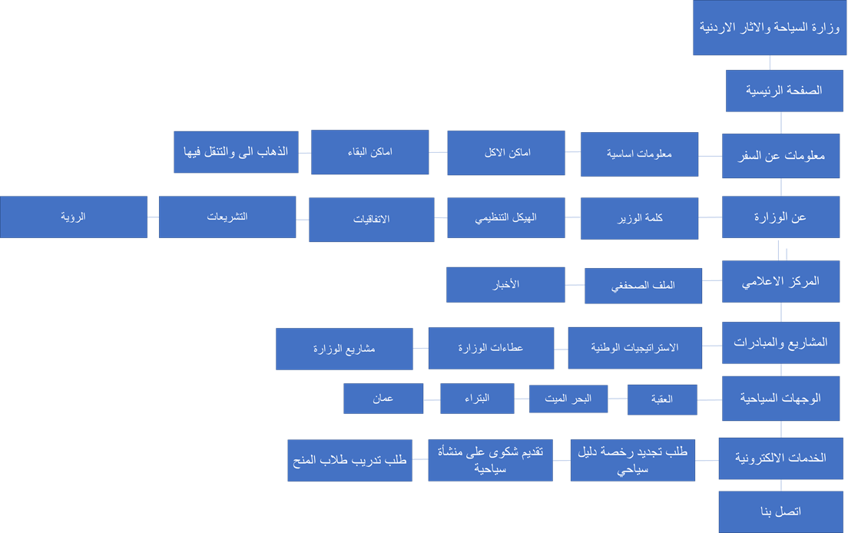

### 

### wireframe

Figure 2 Wireframe for Home page

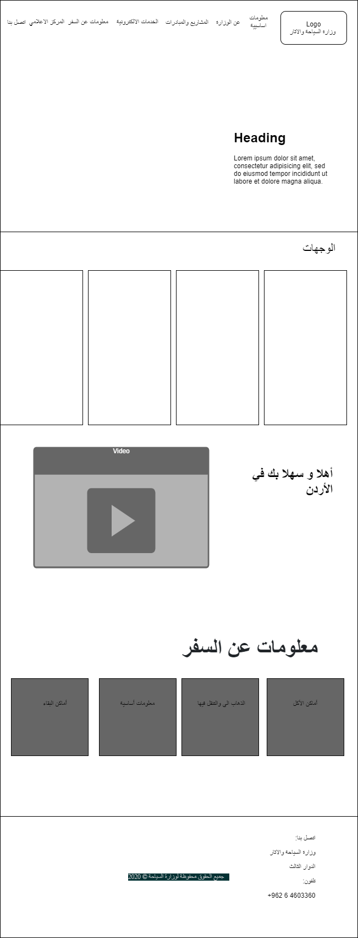

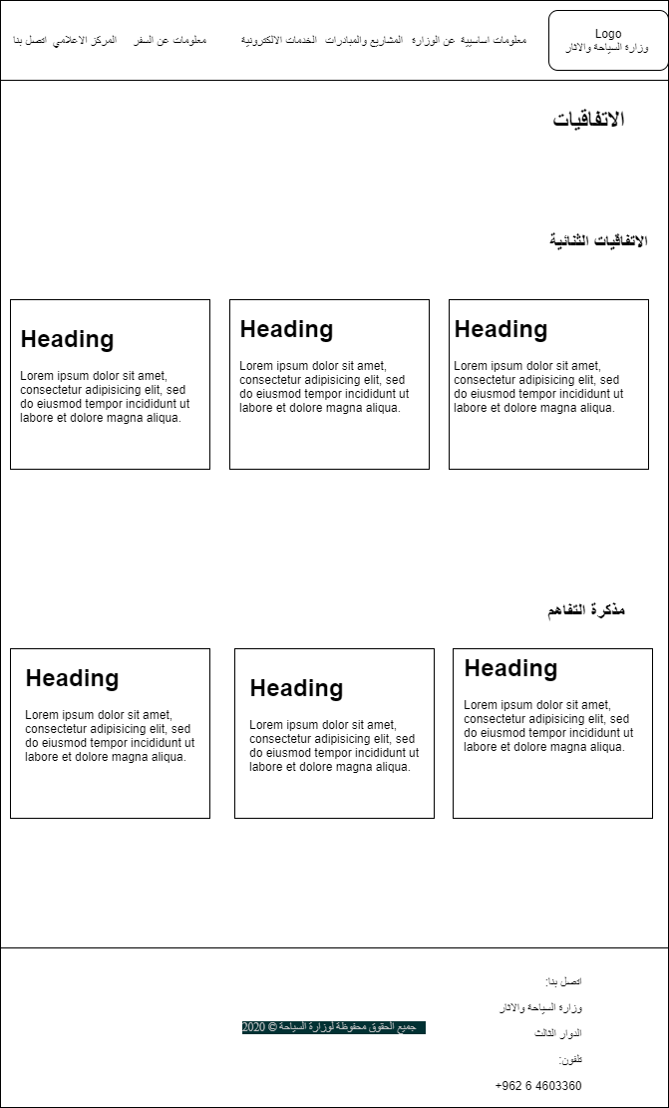

Figure 3 Wireframe for conventions

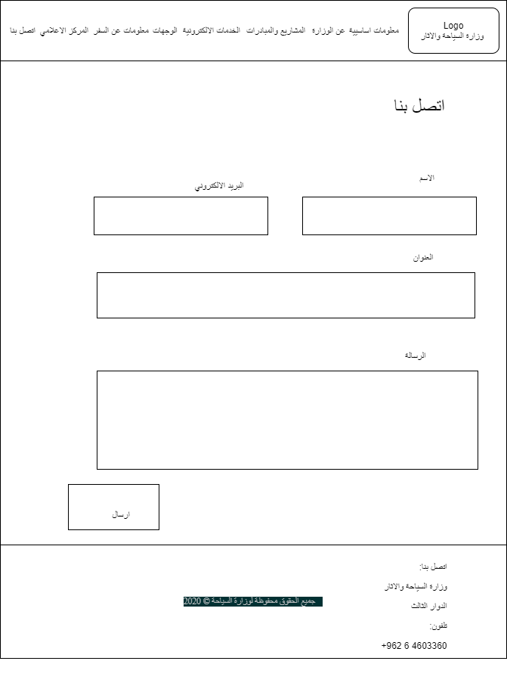

Figure 4 Wireframe for contact us

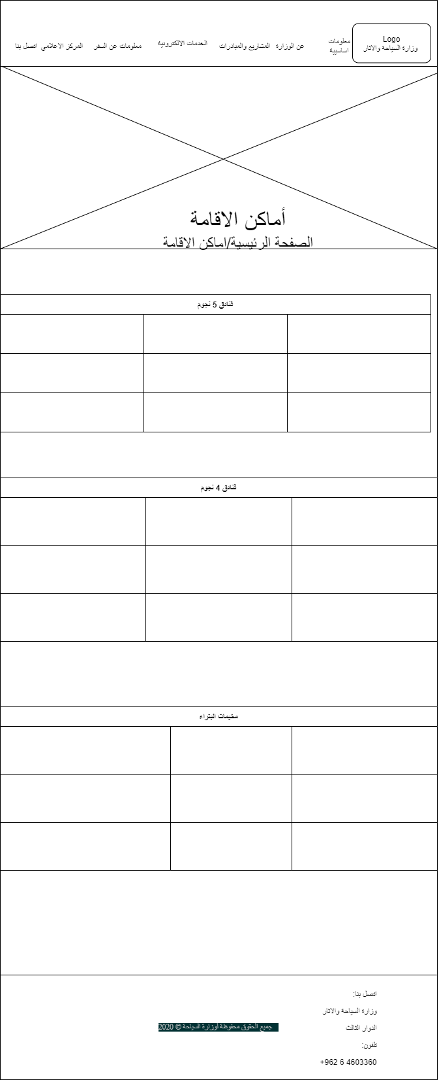

Figure 5 Wireframe for where to stay page

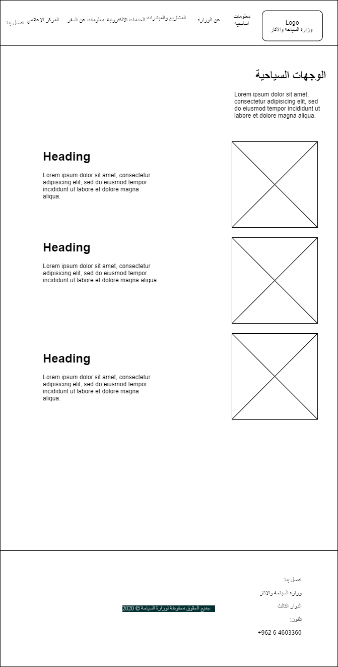

Figure 6 Wireframe for destination

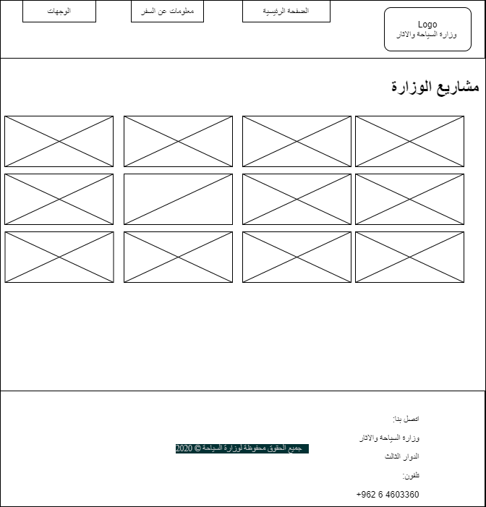

Figure 7 Wireframe for ministry projects

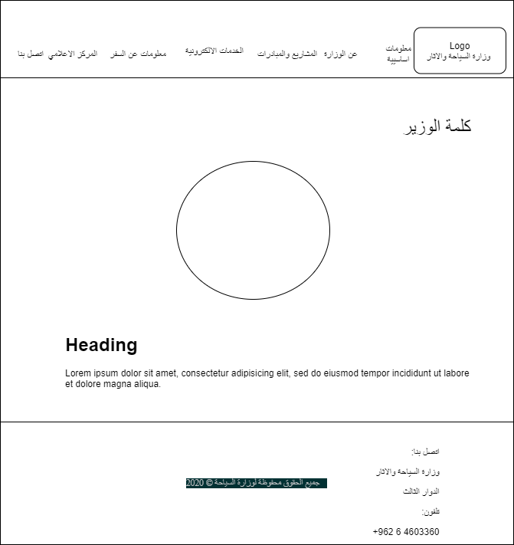

Figure 8 Wireframe for Minister word

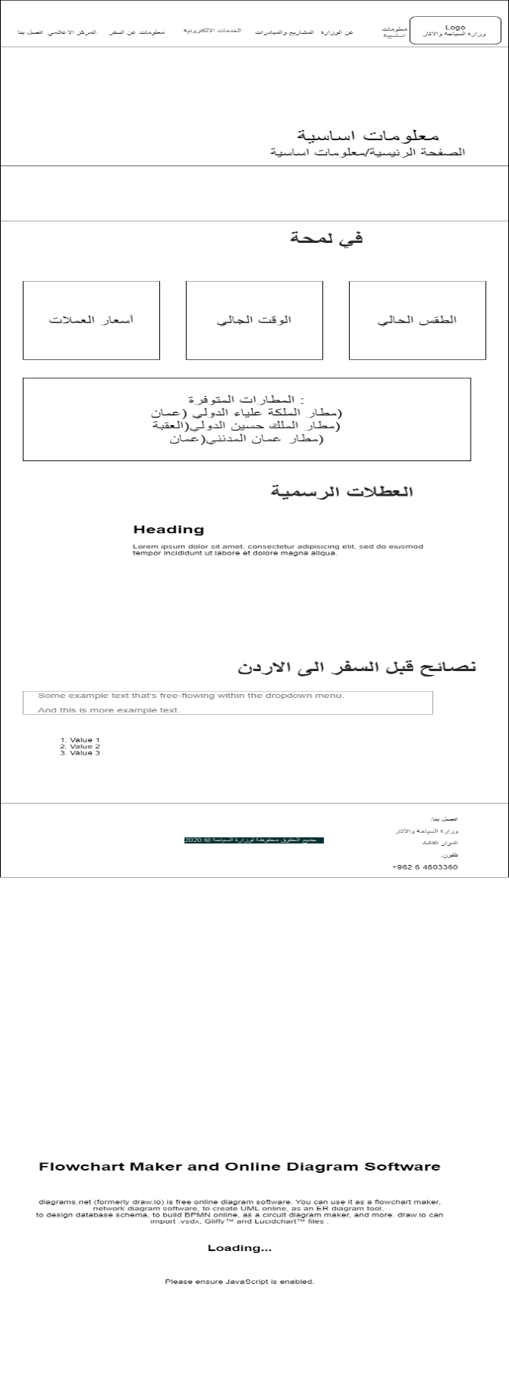

Figure 9 Wireframe for essential information

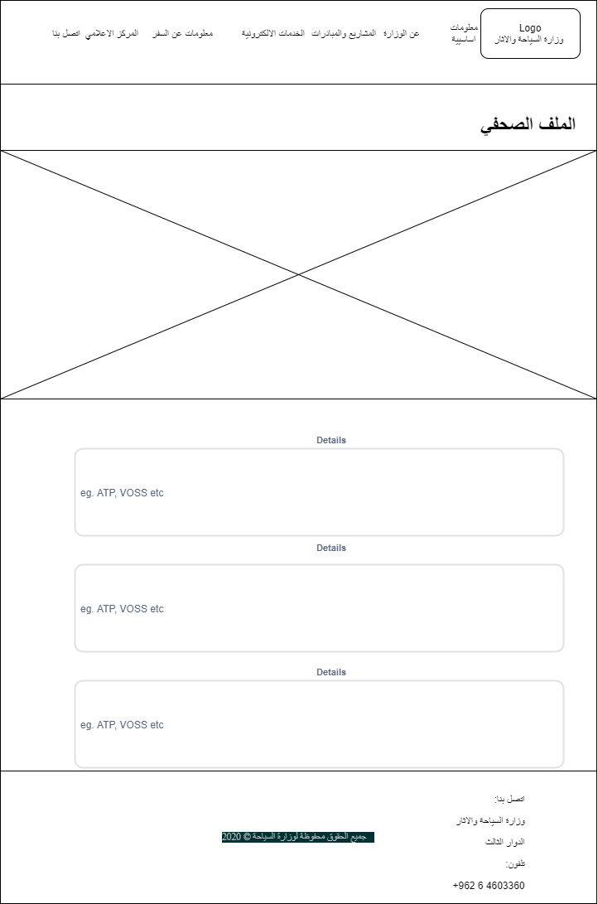

Figure 10 Wireframe for Journalism File

### MockUps

Figure 11 1Mockup for Home page

Figure 12 Mockups for Ministry project

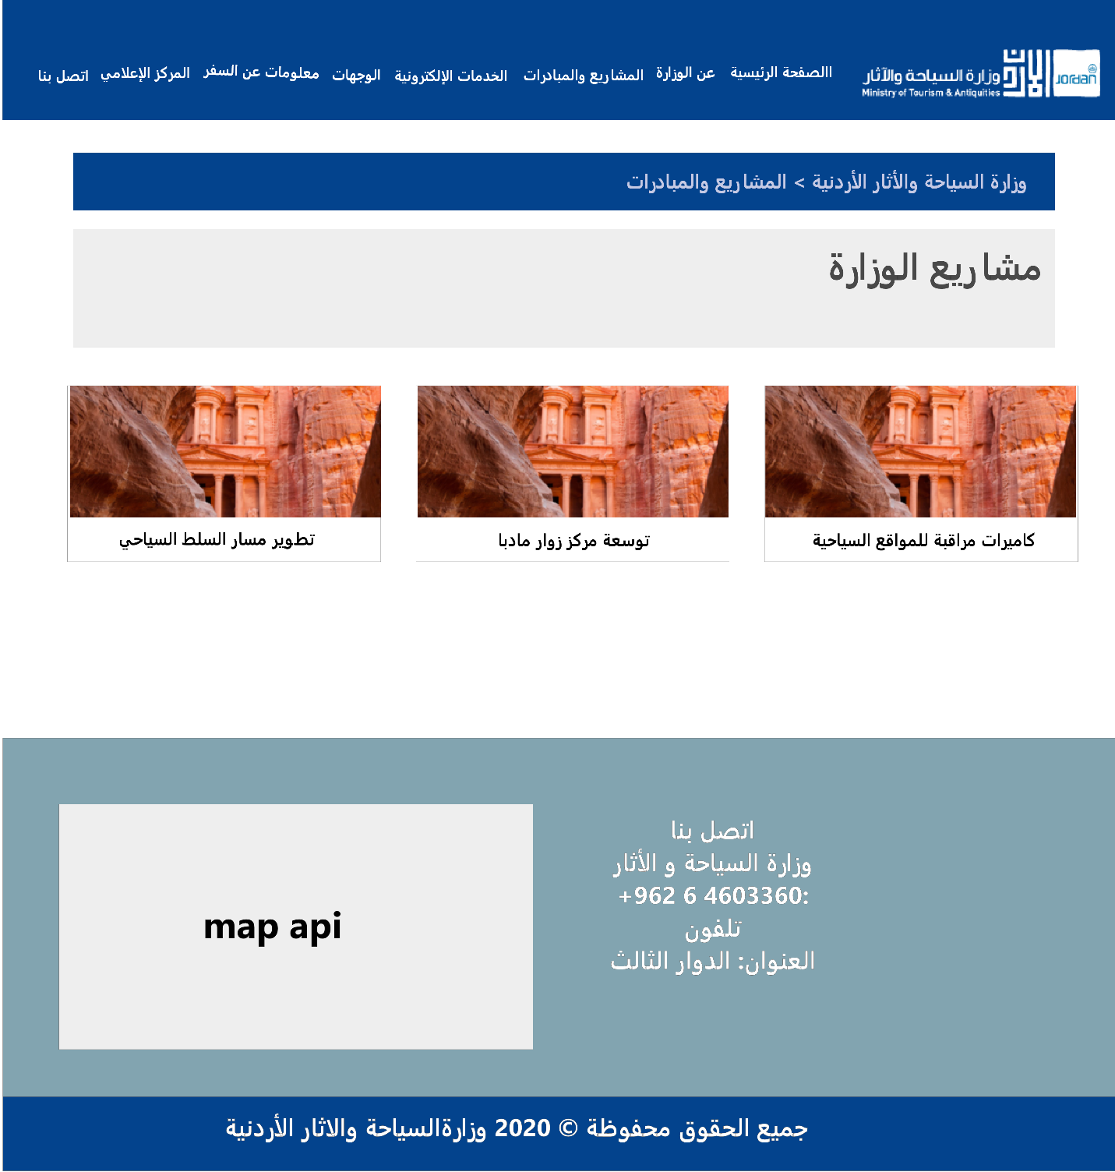

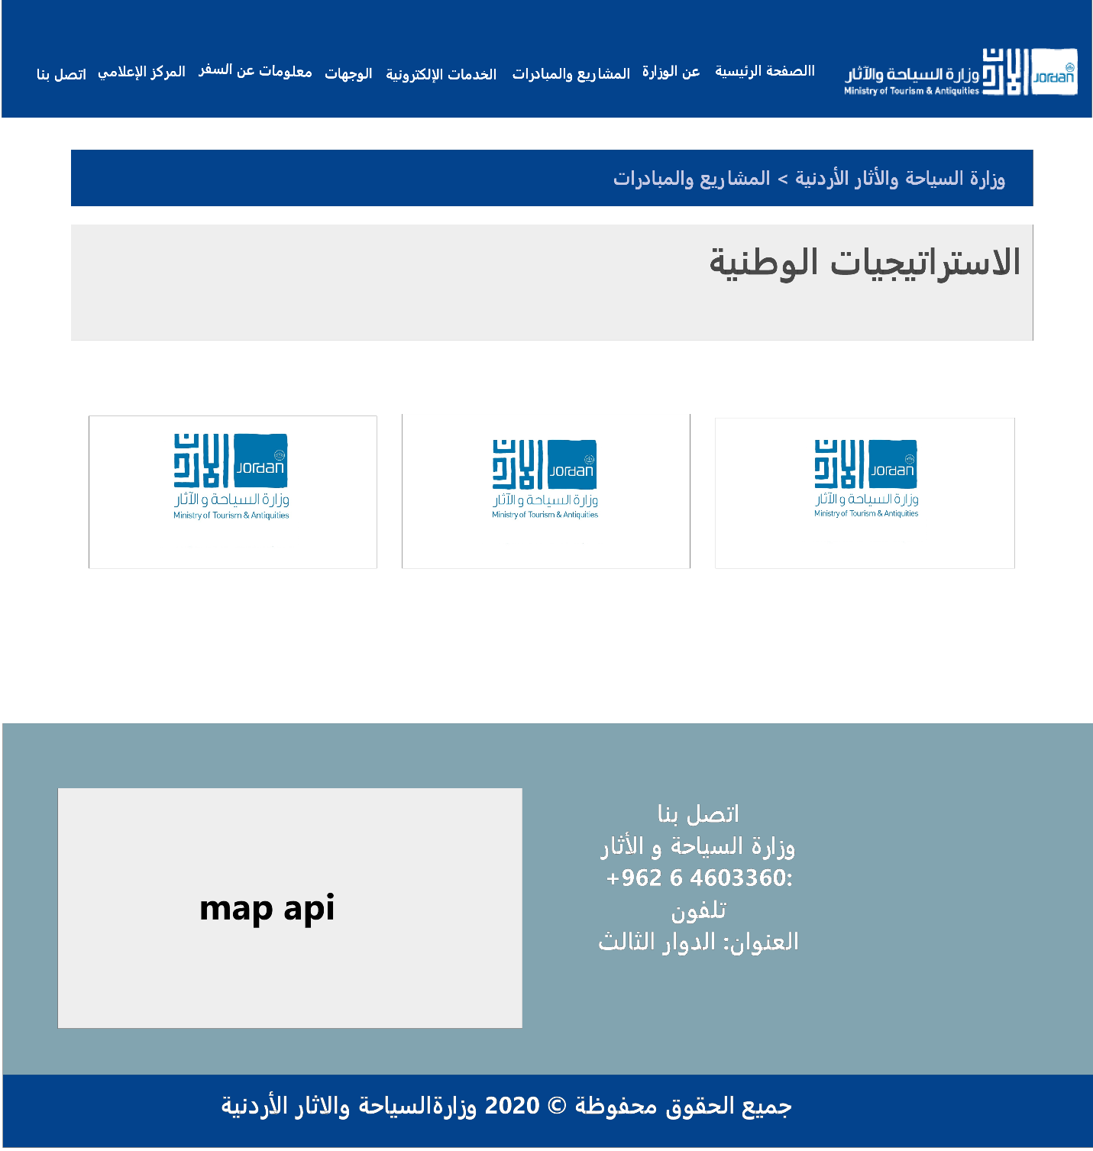

Figure 13 Mockups for national strategy

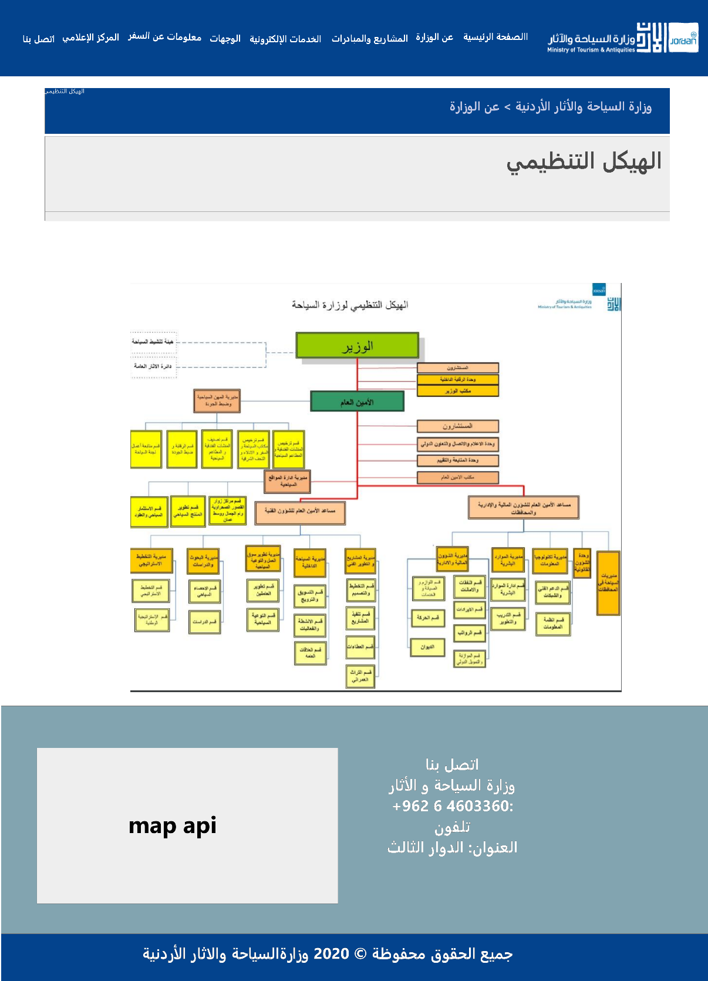

Figure 13 Mockups for organization chart

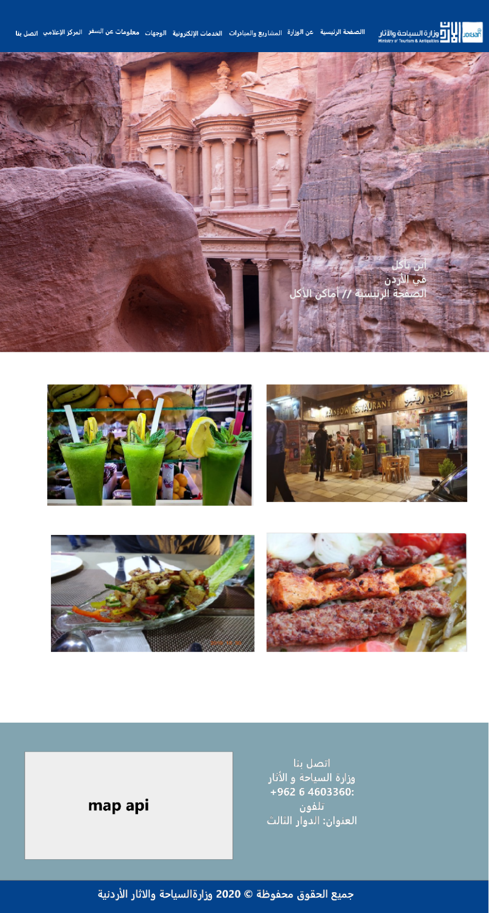

Figure 14 Mockups for where to eat page

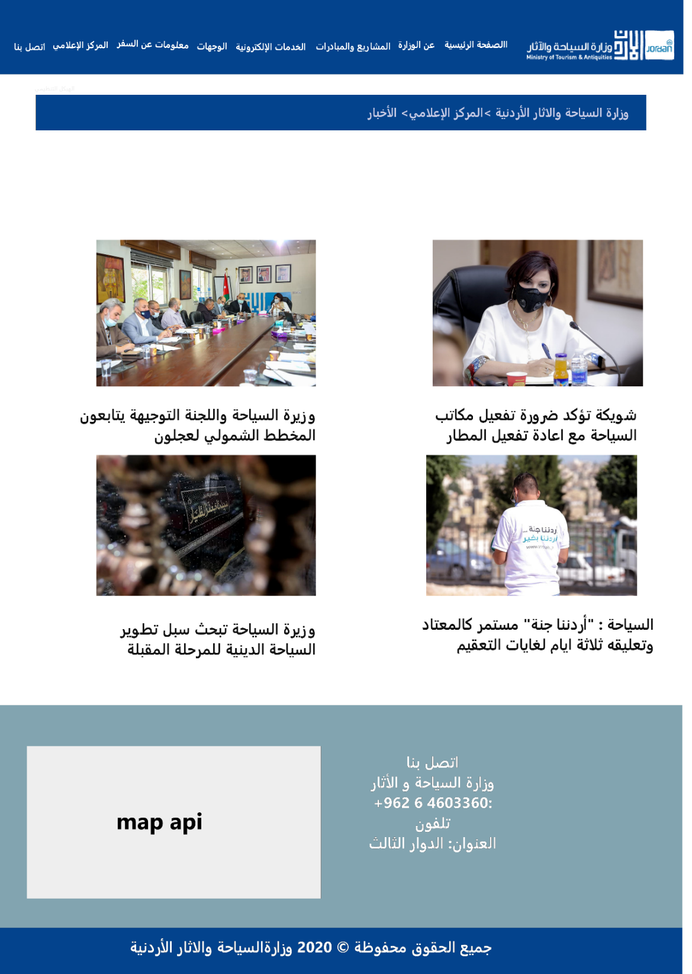

Figure 15 Mockups for news

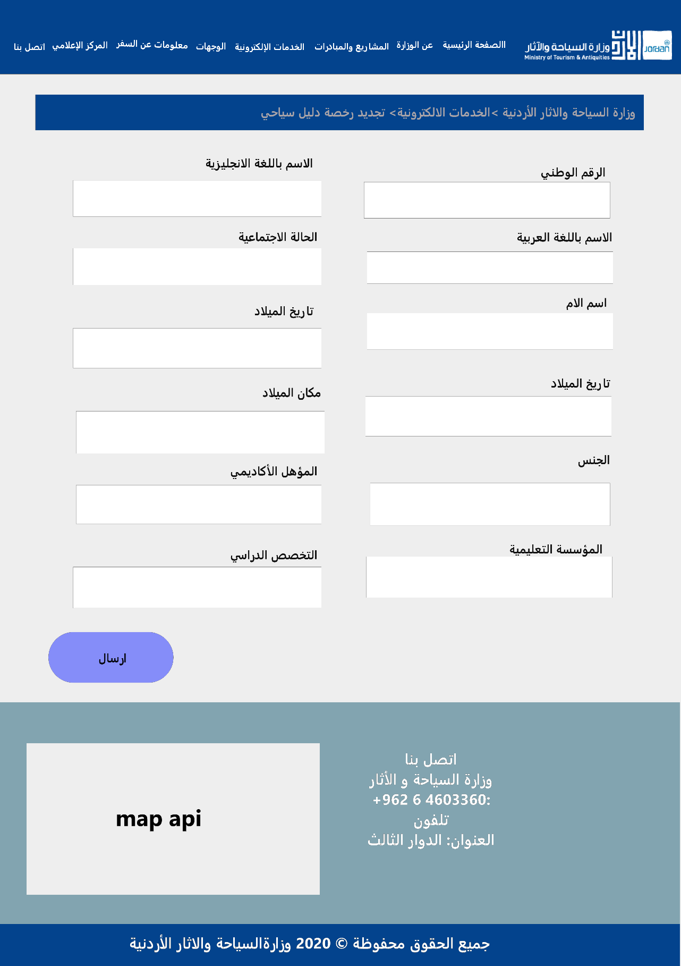

Figure 16 Mockups for renew guide license

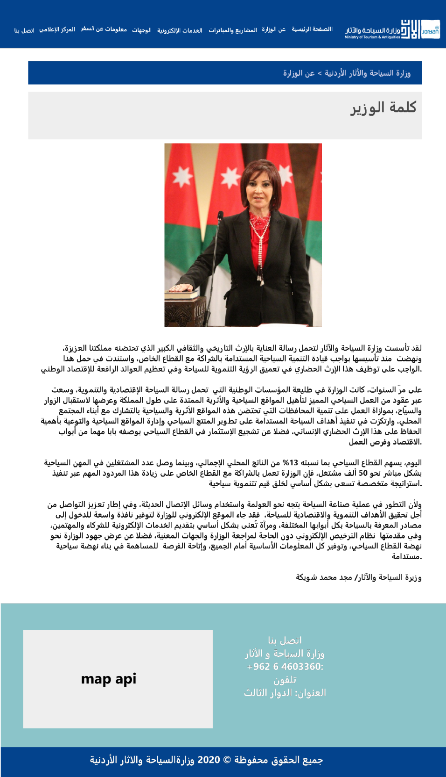

Figure 17 Mockups for minister’s word

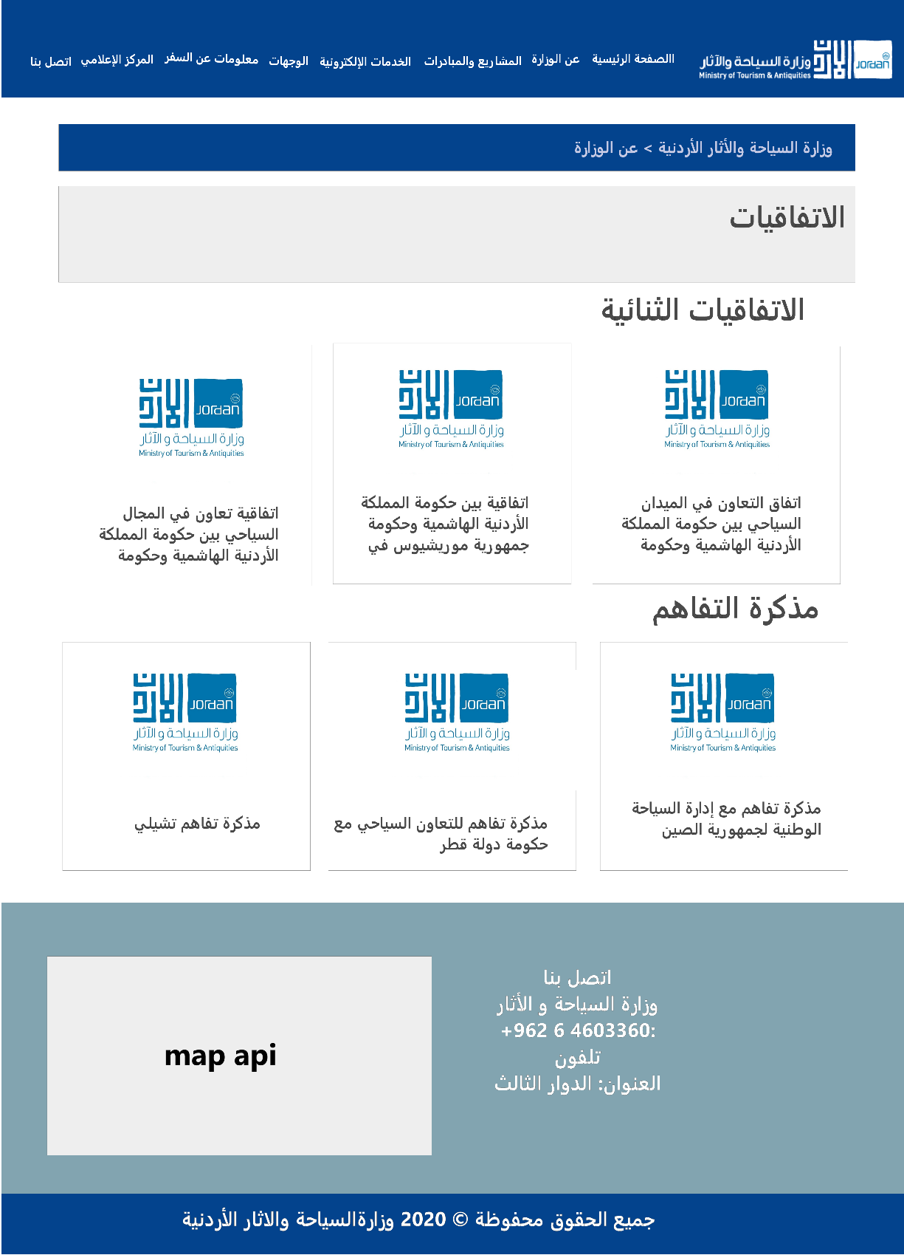

Figure 18 Mockups for conventions

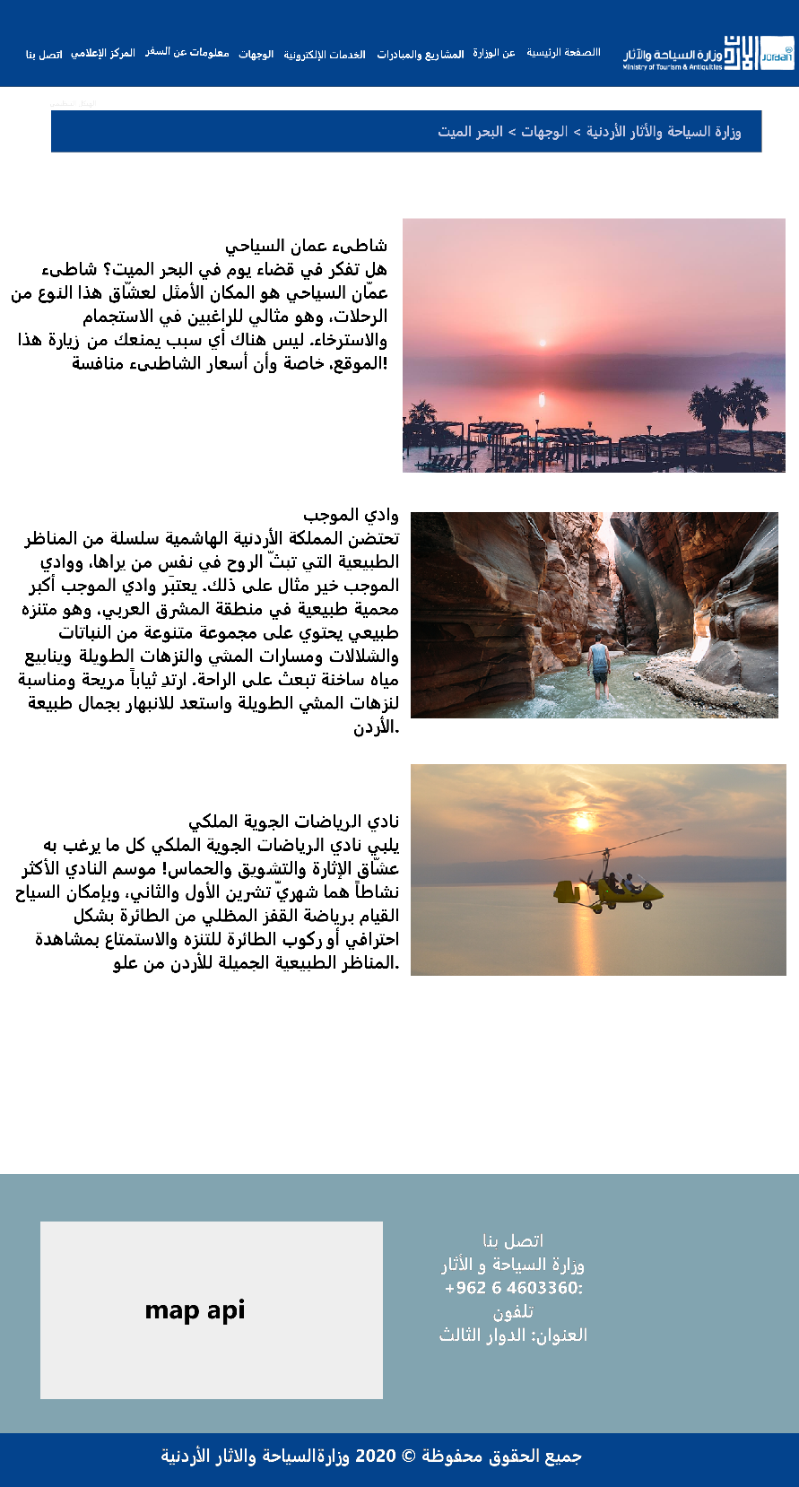

Figure 19 Mockups for destination

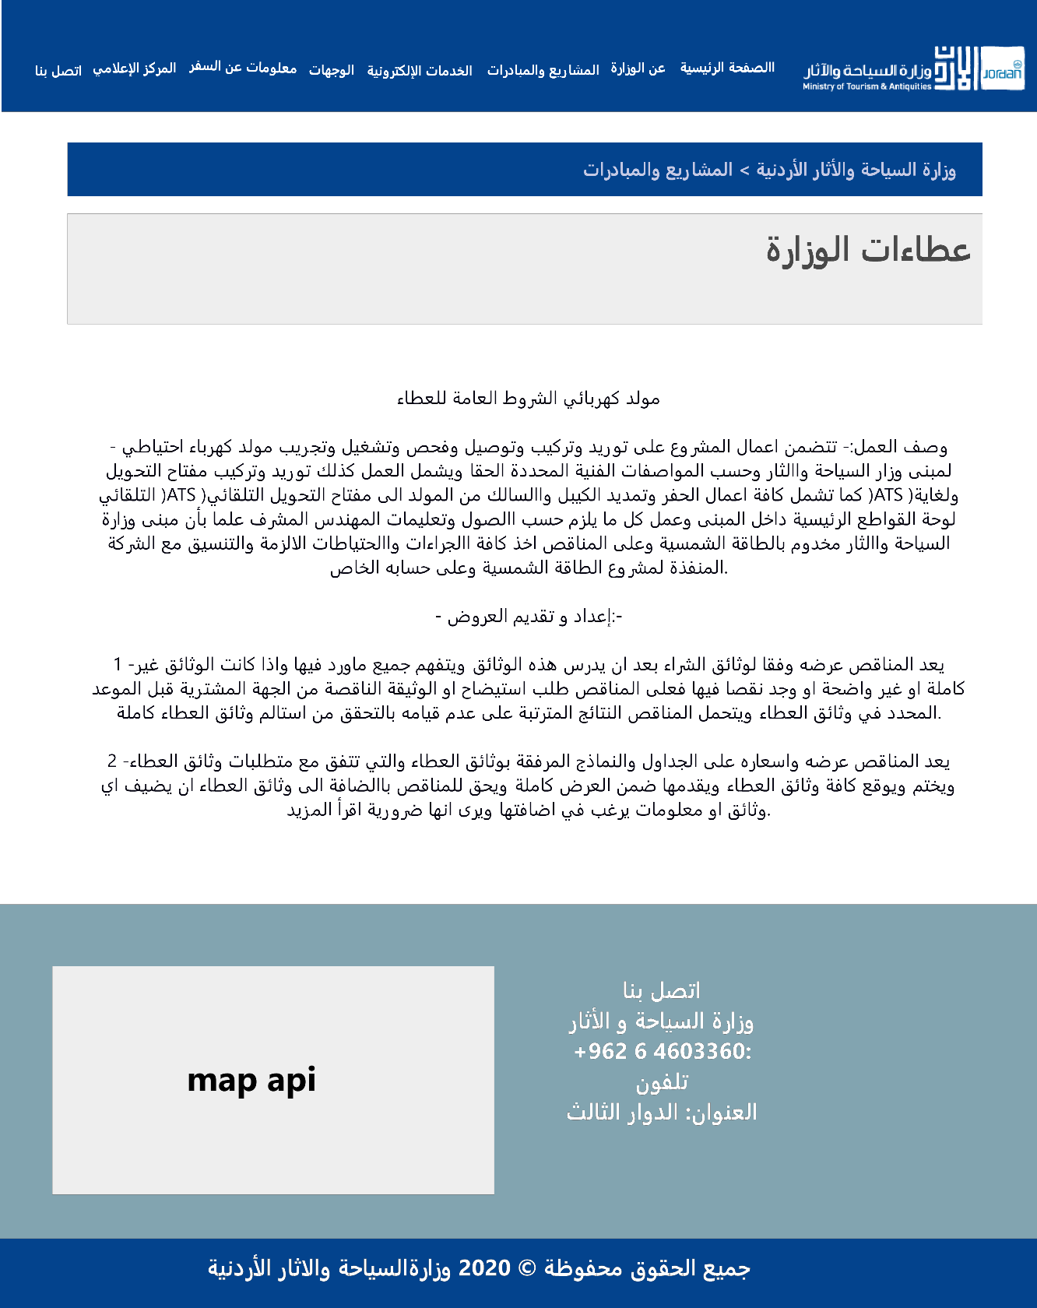

Figure 20 Mockups for bids

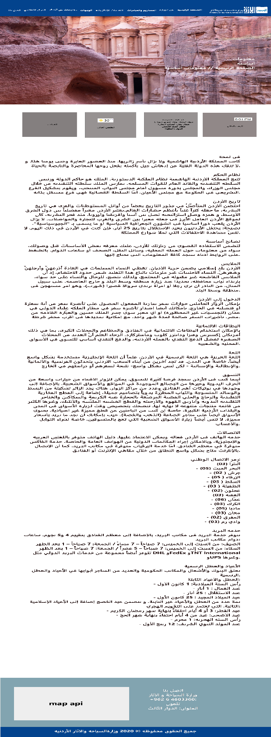

Figure 21 Mockups for essential information

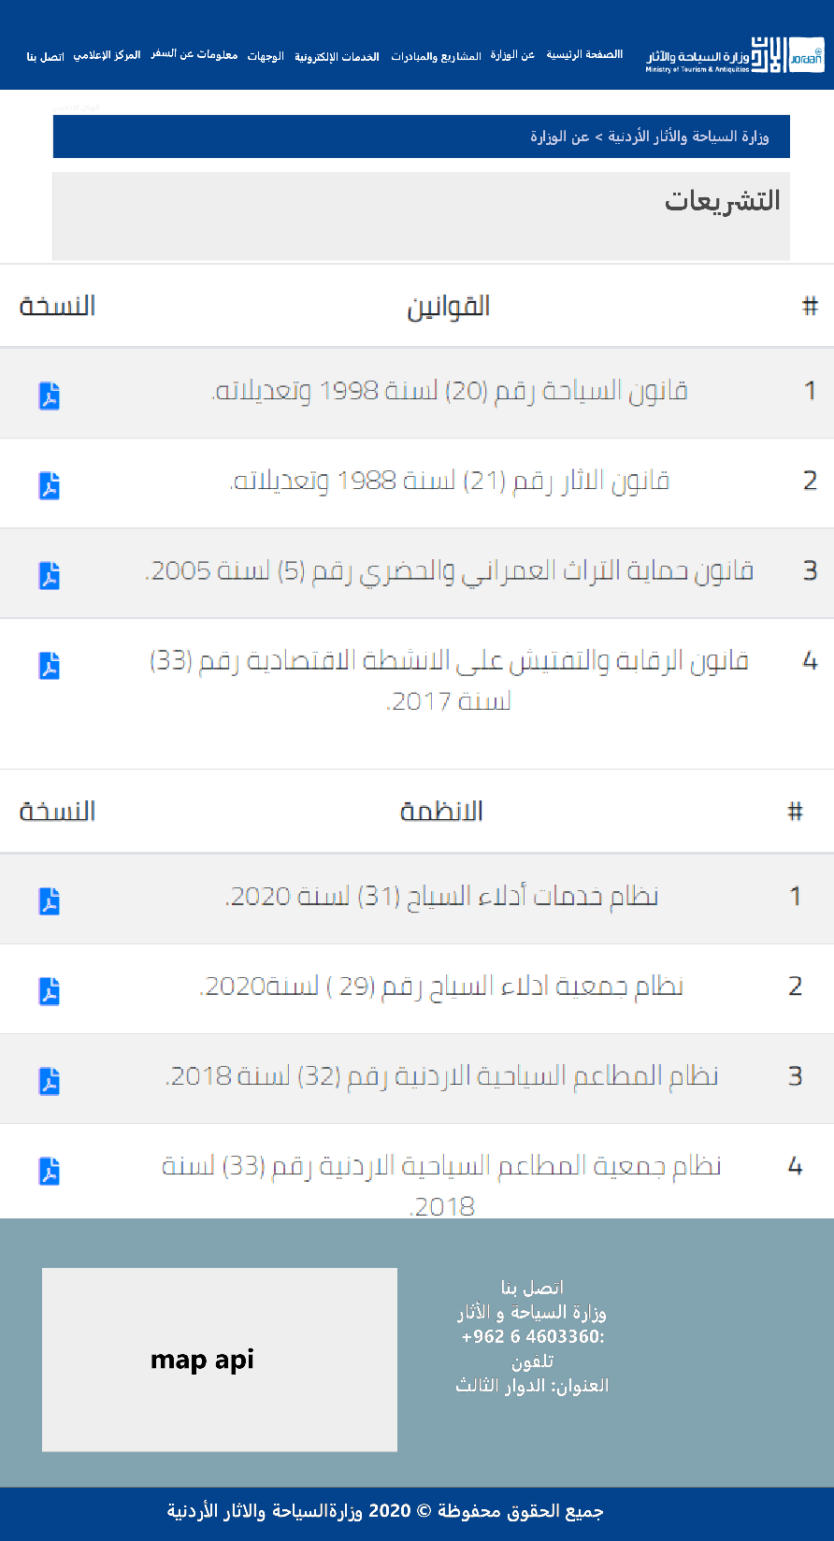

Figure 22 Mockups for regulations



Figure 23 Mockups for national strategies

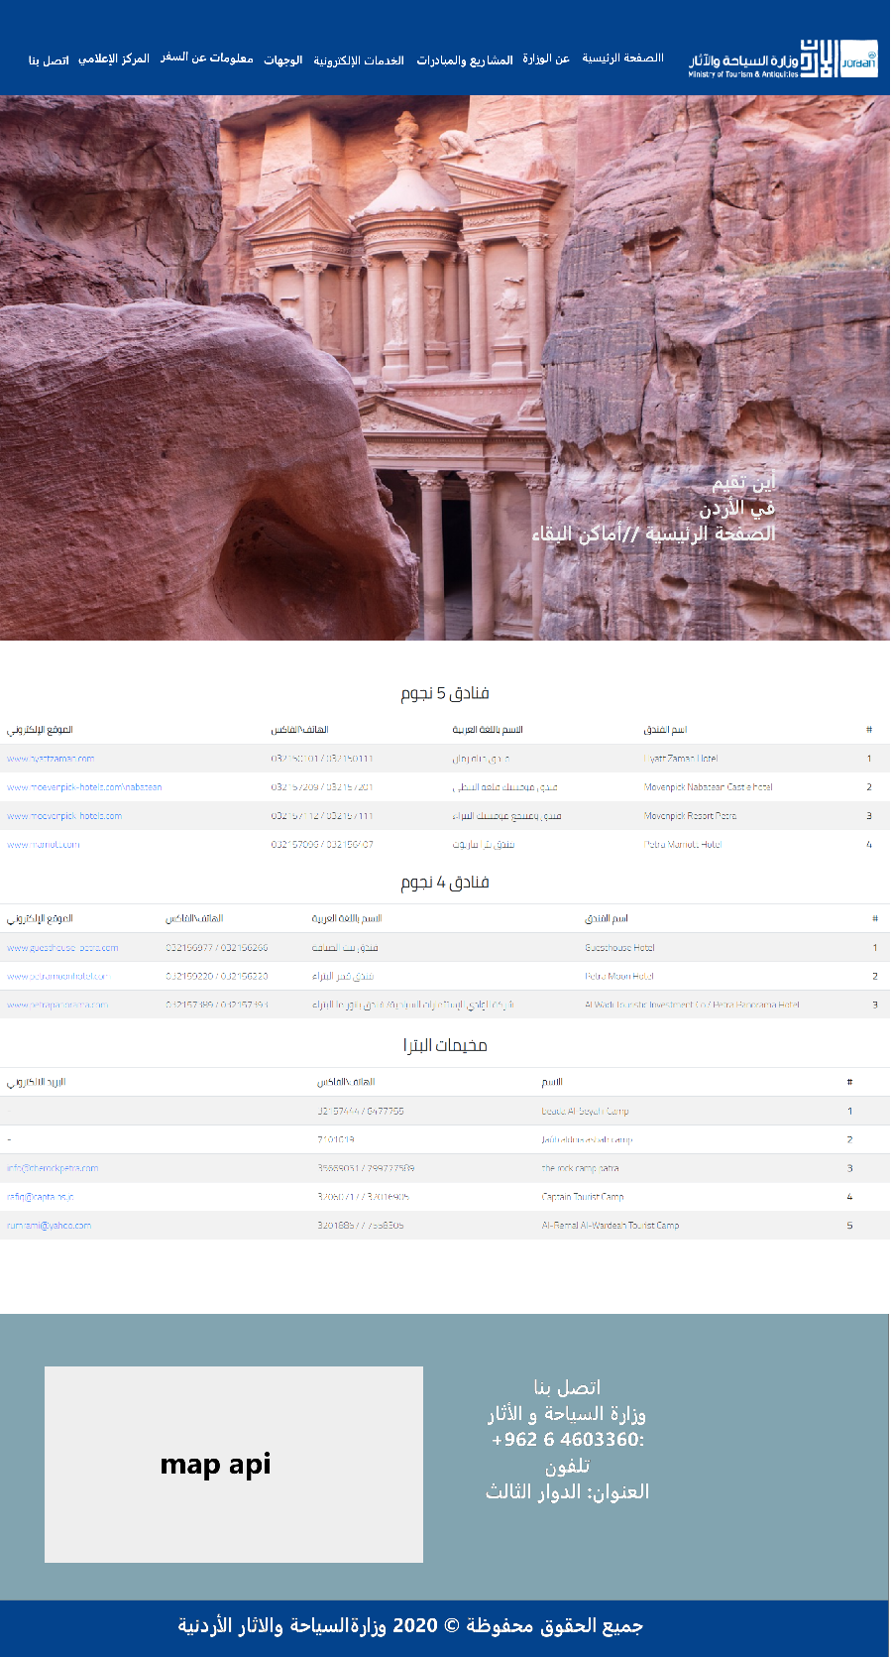

Figure 24 Mockups for where to stay page

### Prototype

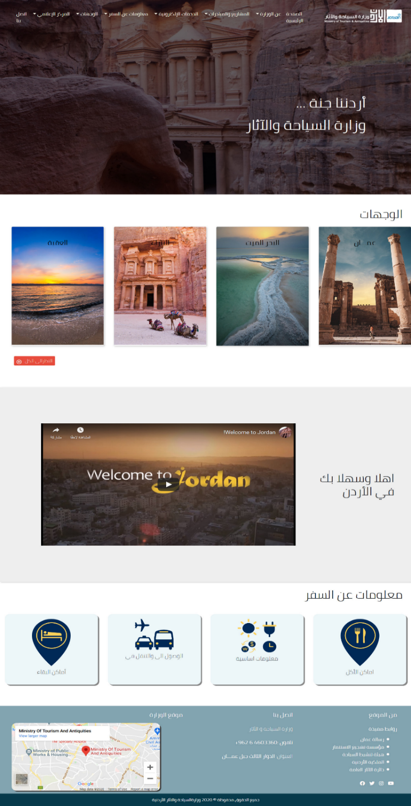

Figure 25 prototype for home page

### ERD

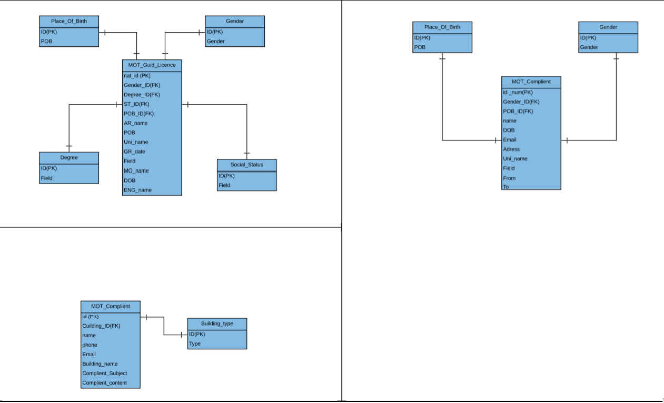

Figure 26 ERD

## Development

Technology used in development:

HTML:  stands for Hyper Text Markup Language. HTML is the standard markup language for creating Web pages. HTML describes the structure of a Web page.

CSS: Cascading Style Sheets is a style sheet language used for describing the presentation of a document written in a markup language such as HTML. CSS is a cornerstone technology of the World Wide Web, alongside HTML and JavaScript.

Java script: JavaScript, often abbreviated as JS, is a programming language that conforms to the ECMAScript specification. JavaScript is high-level, often just-in-time compiled, and multi-paradigm. It has curly-bracket syntax, dynamic typing, prototype-based object-orientation, and first-class functions.

Bootstrap: Bootstrap is a free and open-source CSS framework directed at responsive, mobile-first front-end web development. It contains CSS- and JavaScript-based design templates for typography, forms, buttons, navigation, and other interface components.

PHP: is a general-purpose scripting language especially suited to web development but it now stands for the recursive initialism.

MySQL: is an open-source relational database management system. Its name is a combination of "My", the name of co-founder Michael Wideness’s daughter, and "SQL", the abbreviation for Structured Query Language.

### Services:

#### 1-license form:

a form that provides the ability to renew a guide license by just filling all required fields.

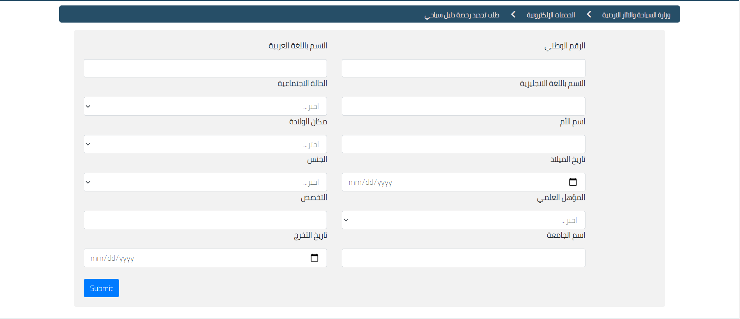

### 2-Submit a compliant:

a form that provides the ability to submit a compliant by filling all the required fields

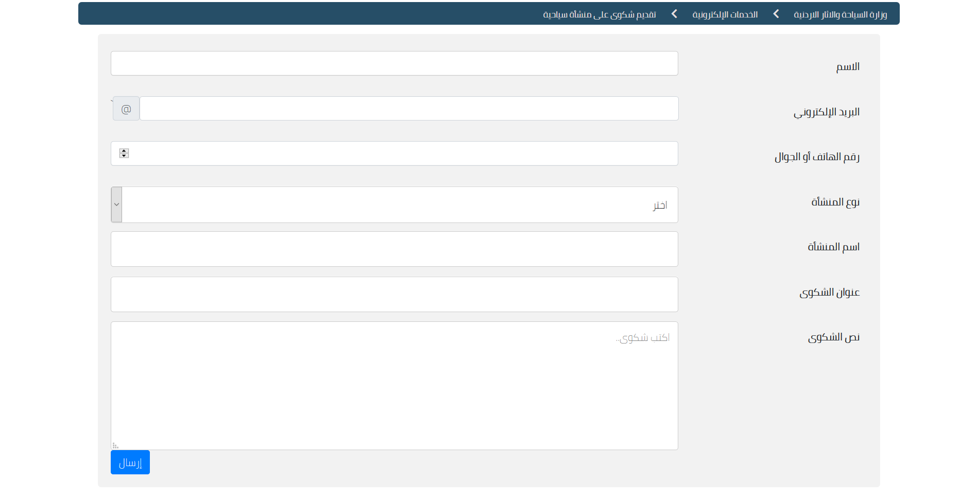

#### 3-Apply for training program:

A form that provides the ability to apply for training.

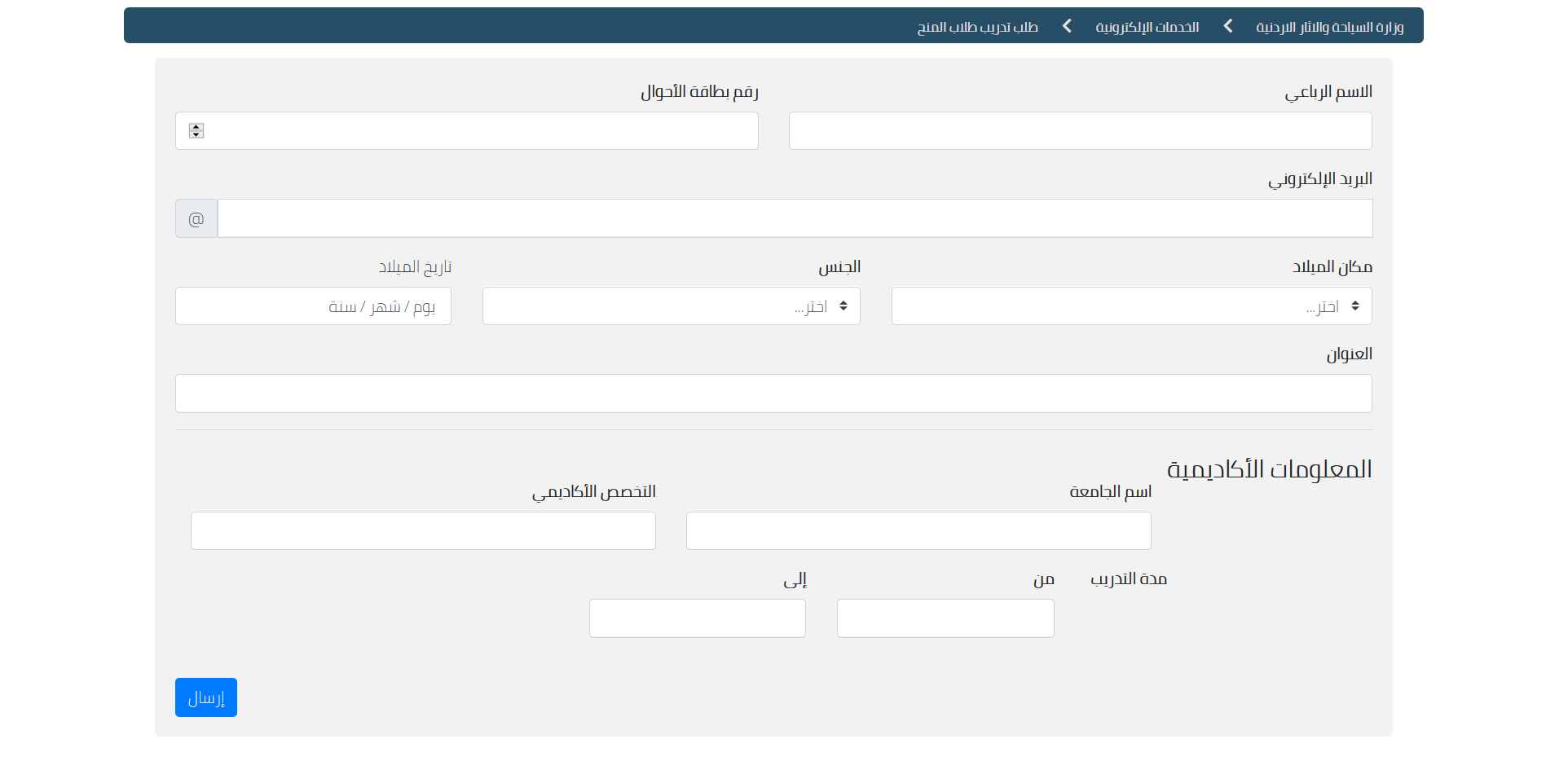

## Testing

Test Cases for e-services by assuming some client requirements, such as: Name, National ID and other field as mandatory fields. There is a submit button at the bottom of the form.

I considered the priority of the test case as P1-P5 and p5 is the highest priority and p1 is the lowest priority.

N/A: not available.

|  |  |  |  |  |  |  |
| --- | --- | --- | --- | --- | --- | --- |
| TC Id | TestCase Feature | TestCase Description | Priority | Steps To Execute | Test Data | Expected Result |
| TC-01 | Required fields | Check the required fields by not filling any data | P3 | 1. Do not enter any value in the field.  2. Click on the Submit button. | N/A | It should show a message on the mandatory fields |  |  |
| TC-02 | Required fields | Check user should Register by filling all the required fields. | P3 | 1. Enter valid values in the required fields.  2. Click on the Submit button. | N/A | 1.The Form should be Submitted successfully  2.A successfully submission message should show. |  |  |
| TC-03 | Optional Fields | Check all the optional fields when do not fill data. | P2 | 1. Do not enter any details in optional fields  2. Enter valid data in required fields.  3. Click on the Submit button. | N/a | 1. It should not ask to fill the optional fields.  2. The Form should be Submitted successfully.  3. A successfully submission message should show. |  |  |
| Tc-04 | Optional Fields | Check all the optional fields when filling data | P2 | 1. Enter valid data in optional fields 2. Enter valid data in required fields 3. Click on the Submit button | N/a | 1. The Form should be Submitted successfully.  2. A successfully submission message should show |  |  |
| Tc-05 | ID Number Validation | Check the ID number when passing alphanumeric data | P4 | Try to enter alphanumeric data in ID Number field. | 1. dada5$7567#7 | It Should reject all the alphabets and other characters instead of the numbers |  |  |
| Tc-06 | ID Number Validation | Check the ID Number when passing less than 10 numbers | P4 | 1.Enter less than 10 numbers in ID Number field.  2. Enter valid values in the required fields.  3. Click on the Submit button. | 1.998205355 | It should show a Validation message to enter the ID Number |  |  |
| Tc-07 | ID Number Validation | Check the ID Number when passing 10 numbers | P4 | 1.Enter 10 numbers in ID Number field.  2. Enter valid values in the required fields.  3. Click on the Submit button. | 1.9982053555 | 1. The Form should be Submitted successfully.  2. A successfully submission message should show |  |  |
| Tc-08 | Full Name Validation | Check the Full name when passing less than 10 numbers | P3 | 1.Enter less than 6 characters in Name field.  2. Enter valid values in the required fields.  3. Click on the Submit button. | 1.Saba | It should show a Validation message to enter the Name |  |  |
| Tc-09 | Email validation | Check the Email text field that has an Email address without @ symbol. | P3 | 1. Enter Invalid Emails 2. Click on the Register Button. | 1.testAtgmail.com | It should show a Validation message for valid email. |  |  |
| Tc-10 | Email validation | Check all the valid emails | P3 | 1. Enter valid Emails 2. Click on the Register Button | 2.test@gmail.com | It should not show any validation message |  |  |

Table 1 Test Cases

# Screenshots

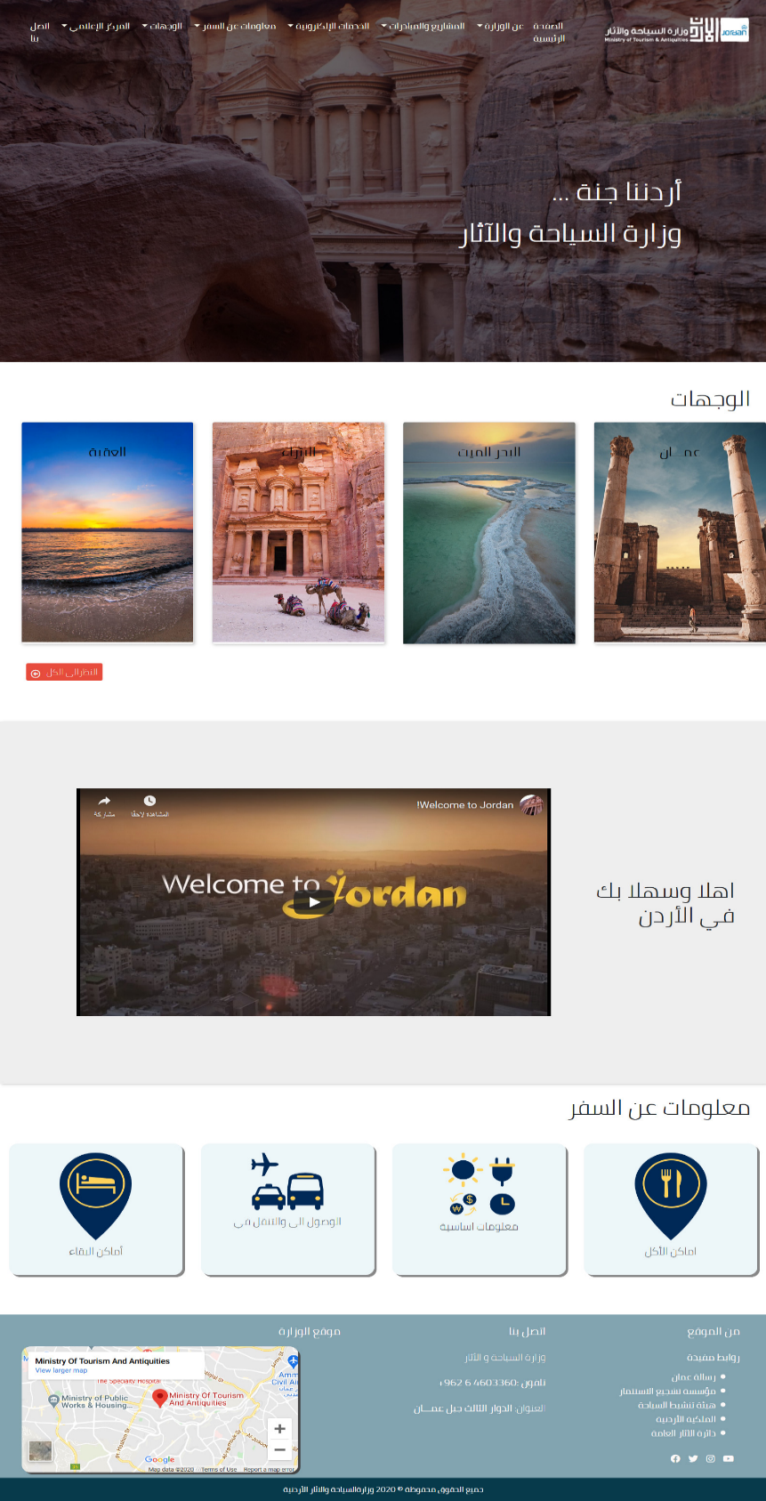

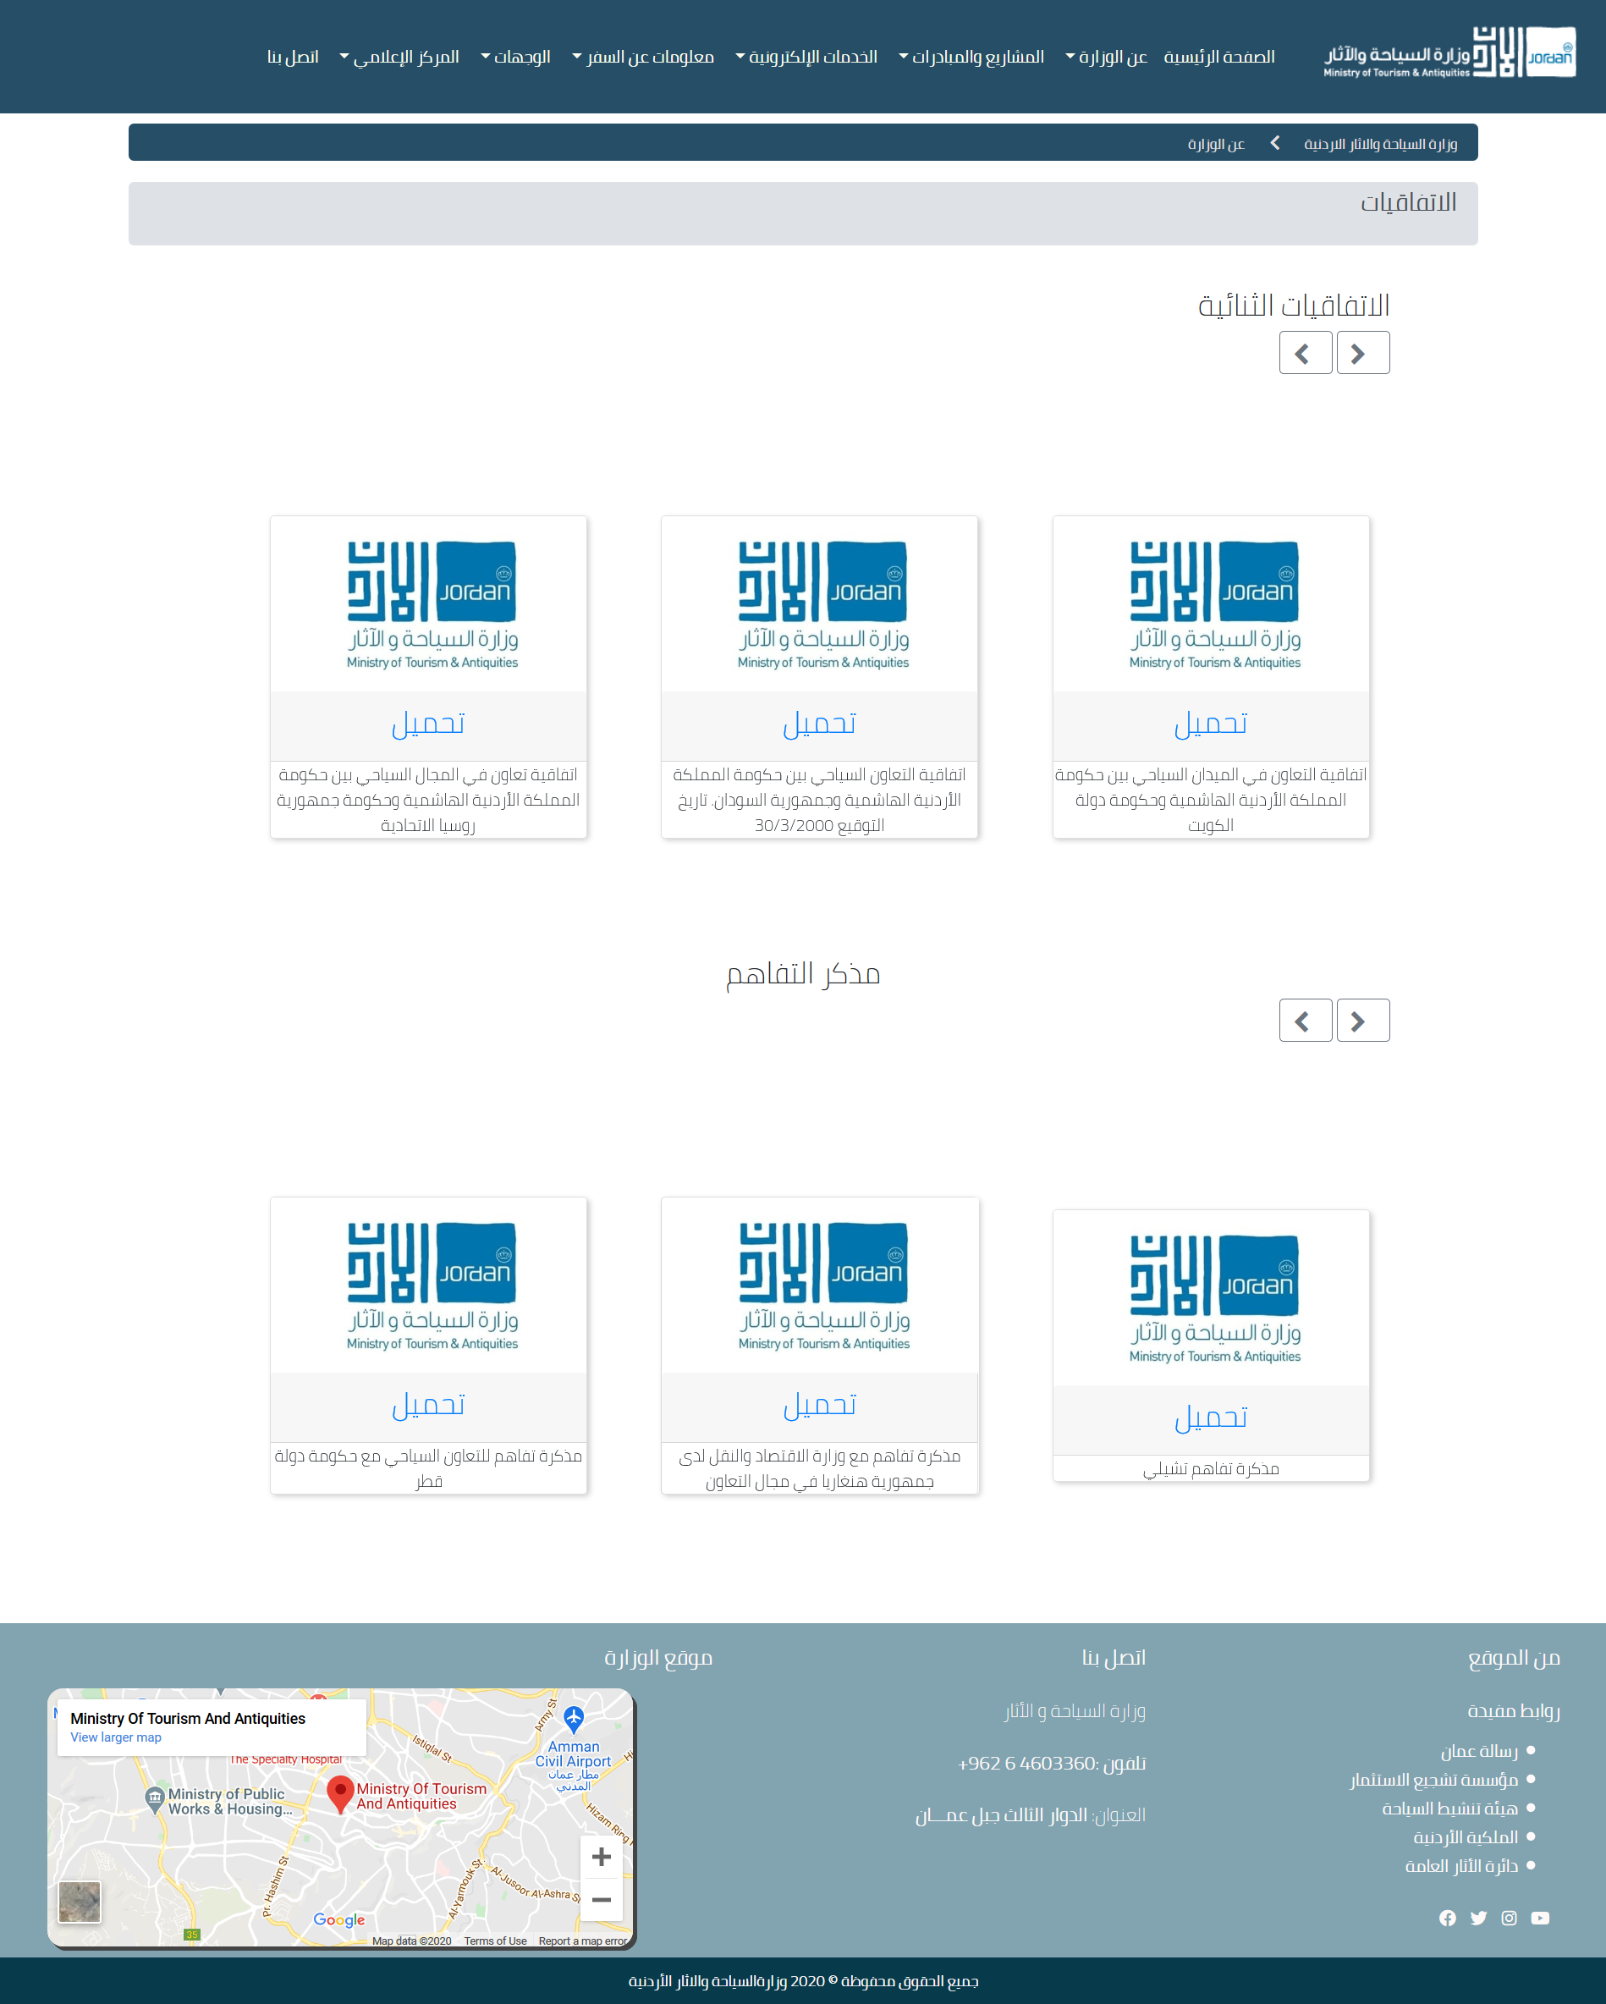

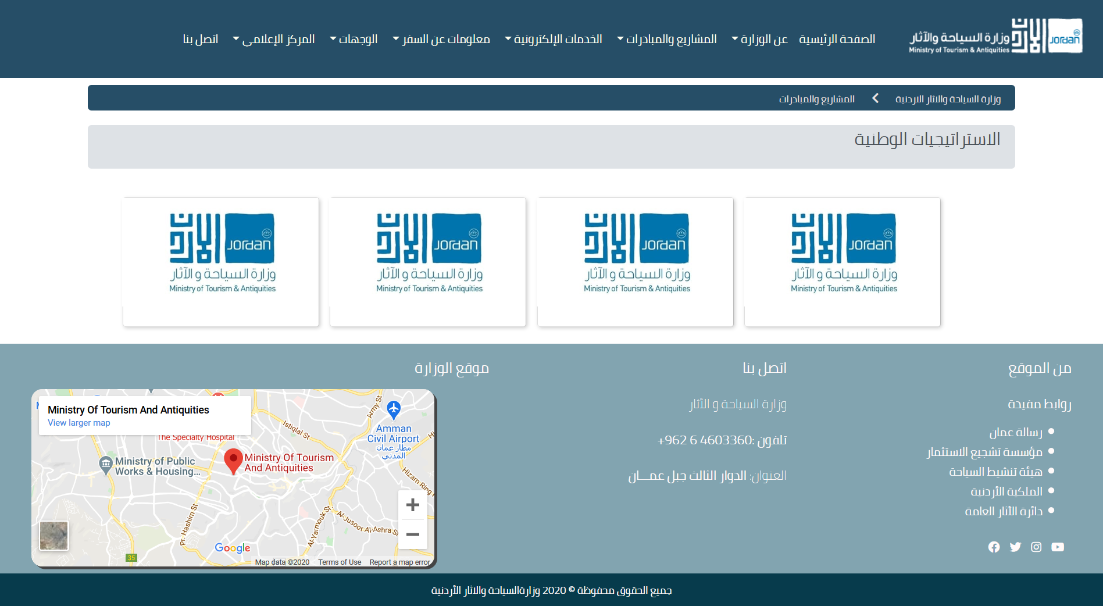

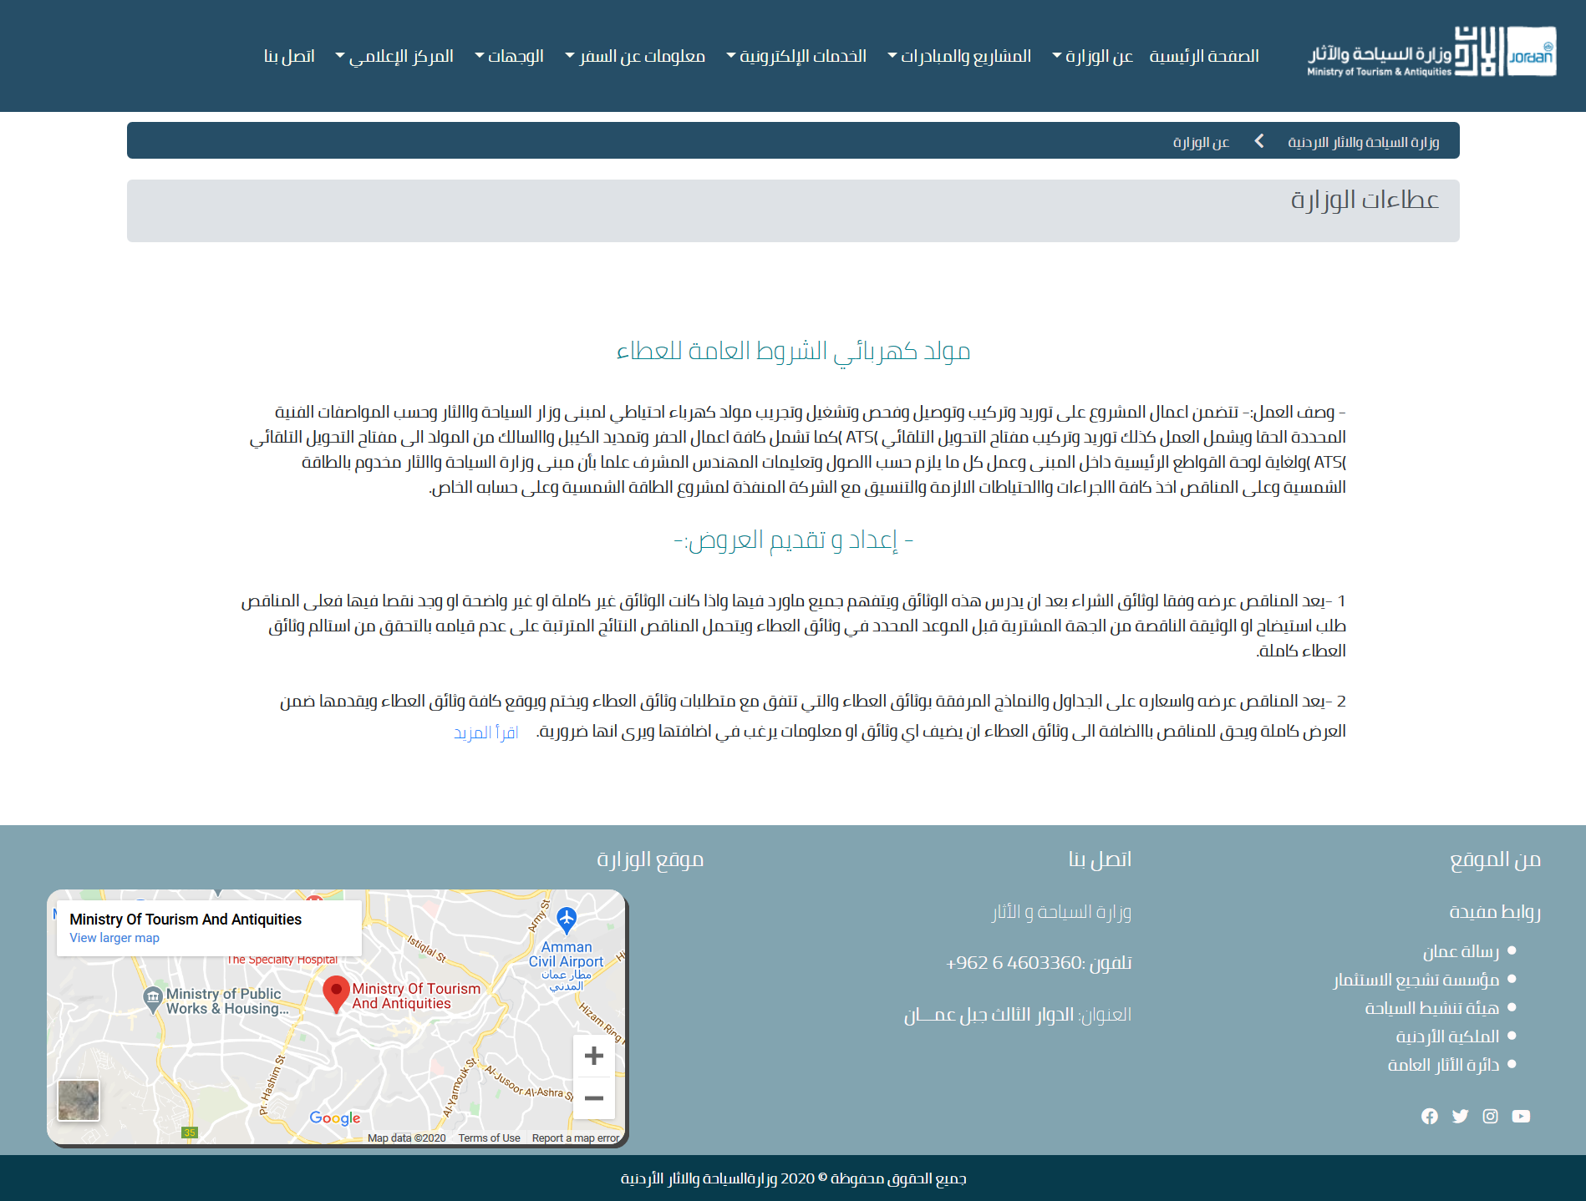

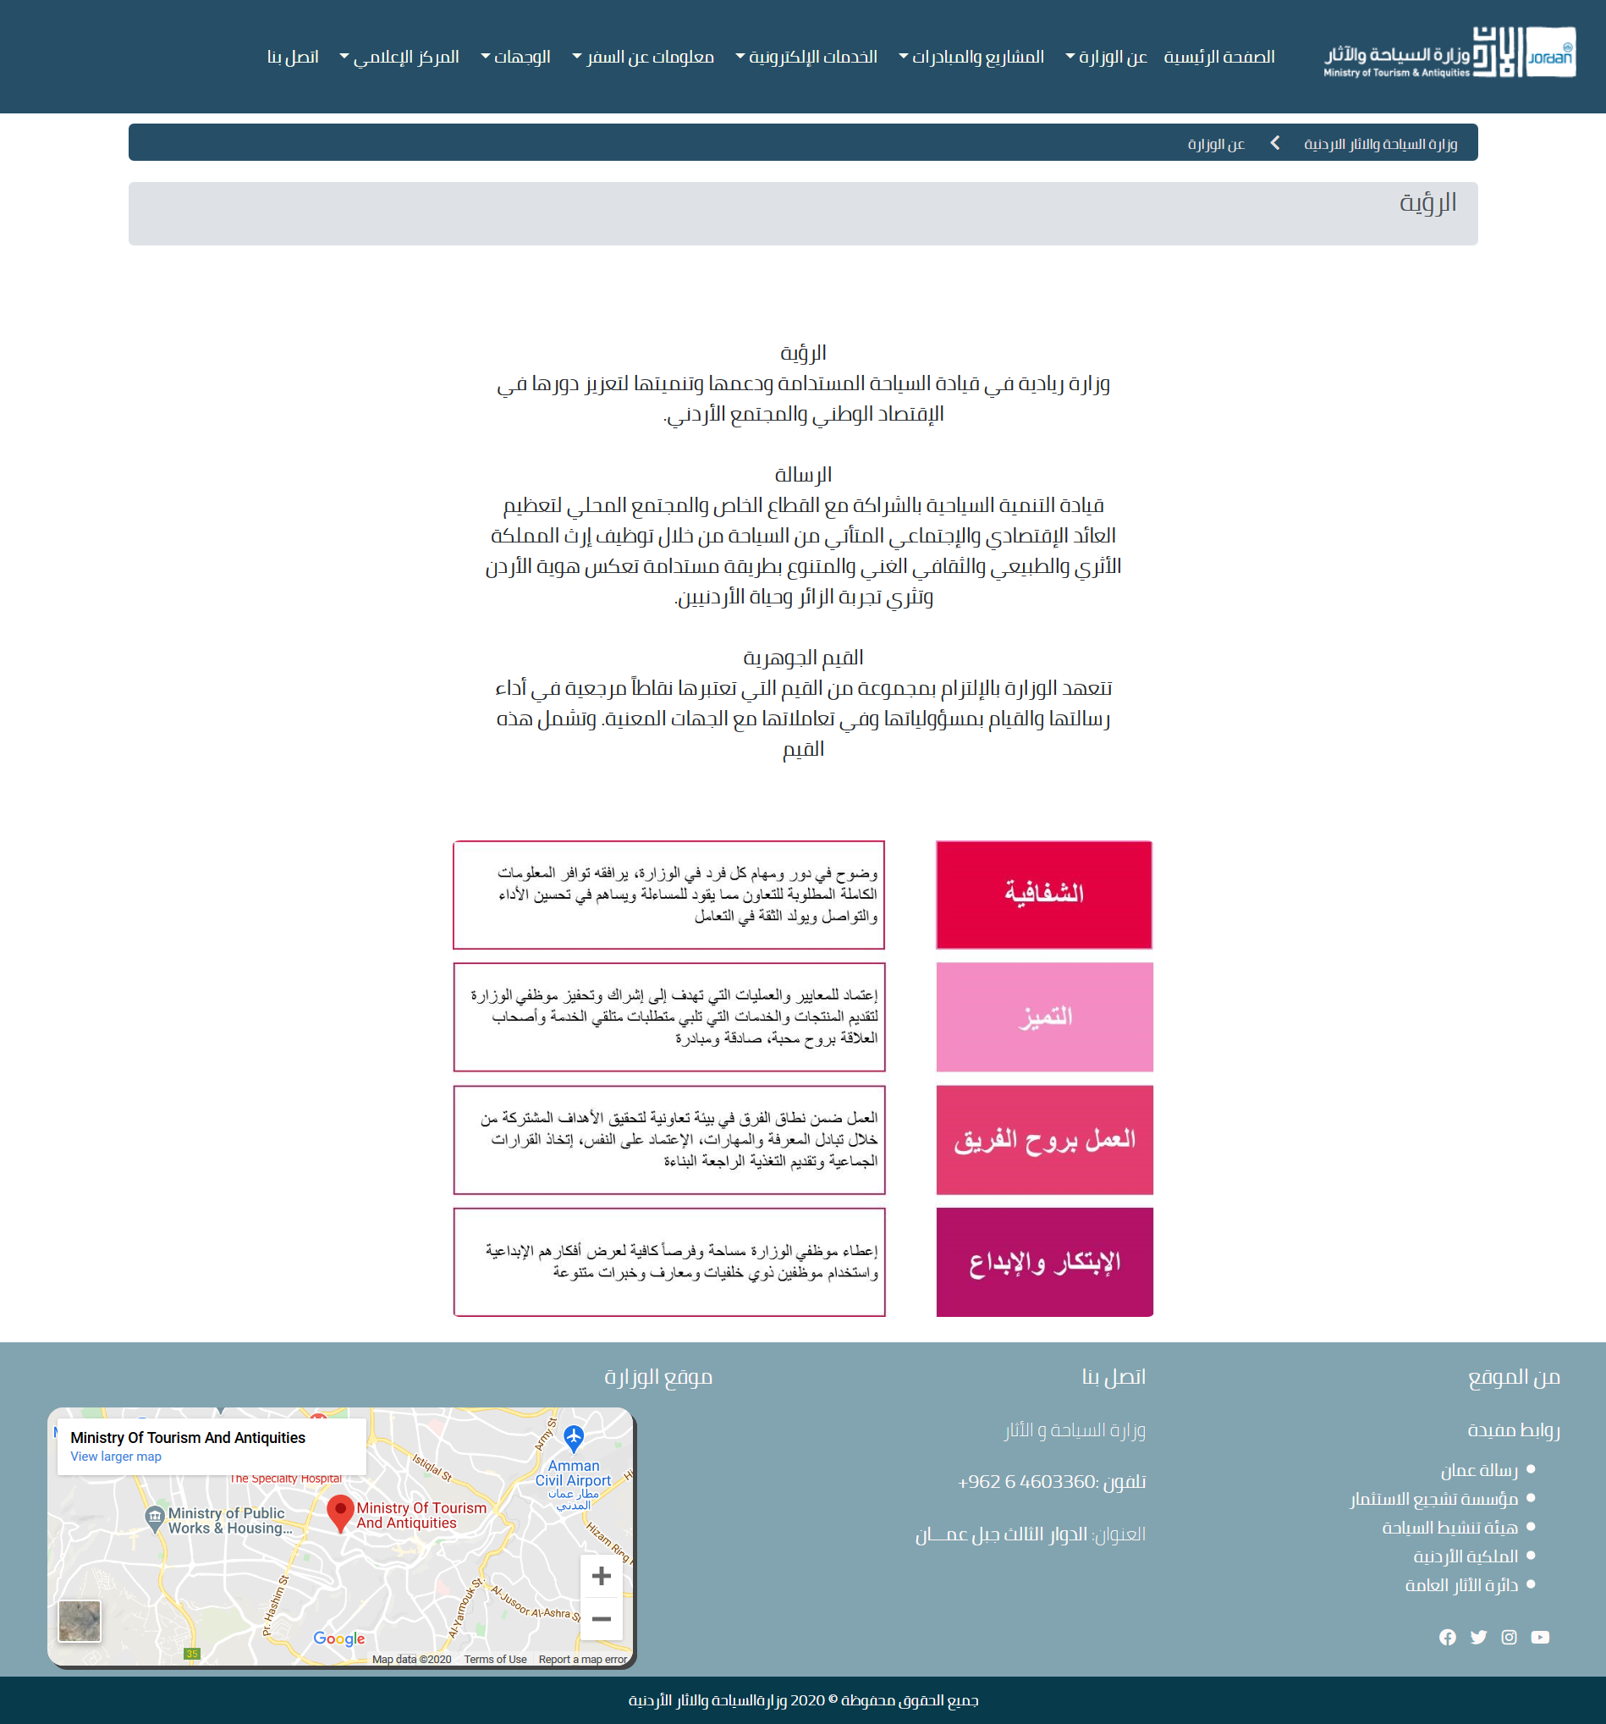

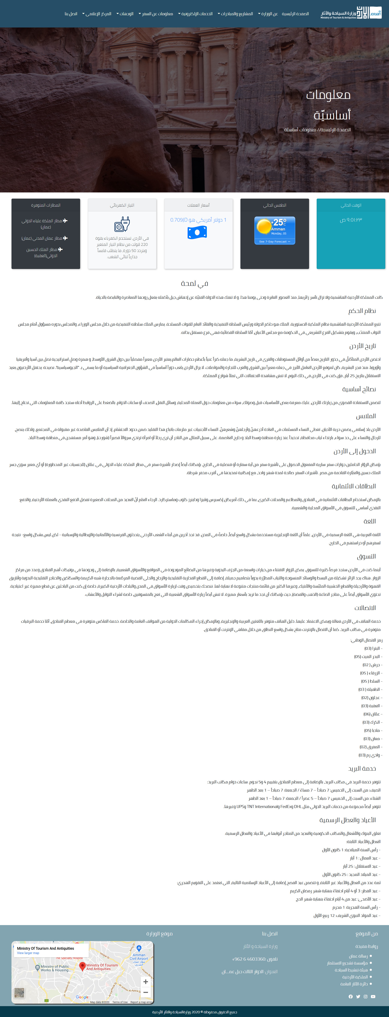

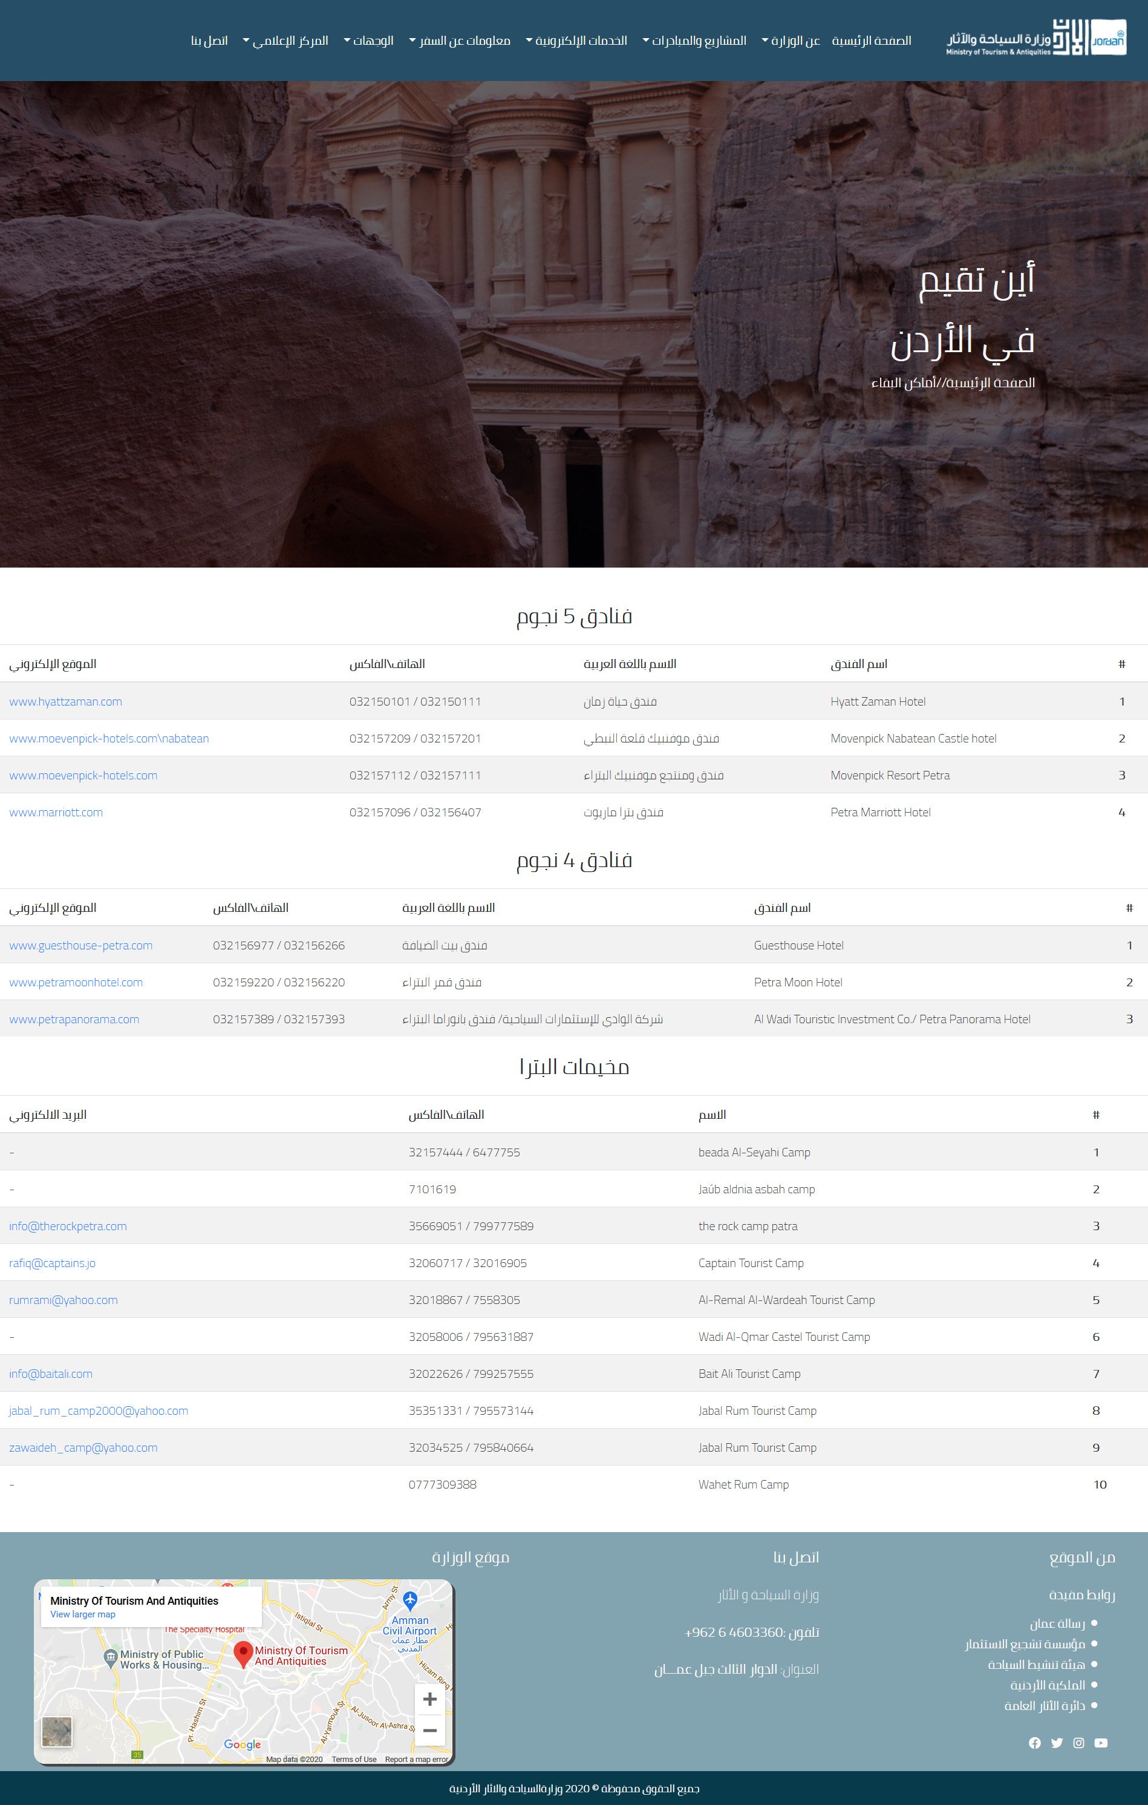

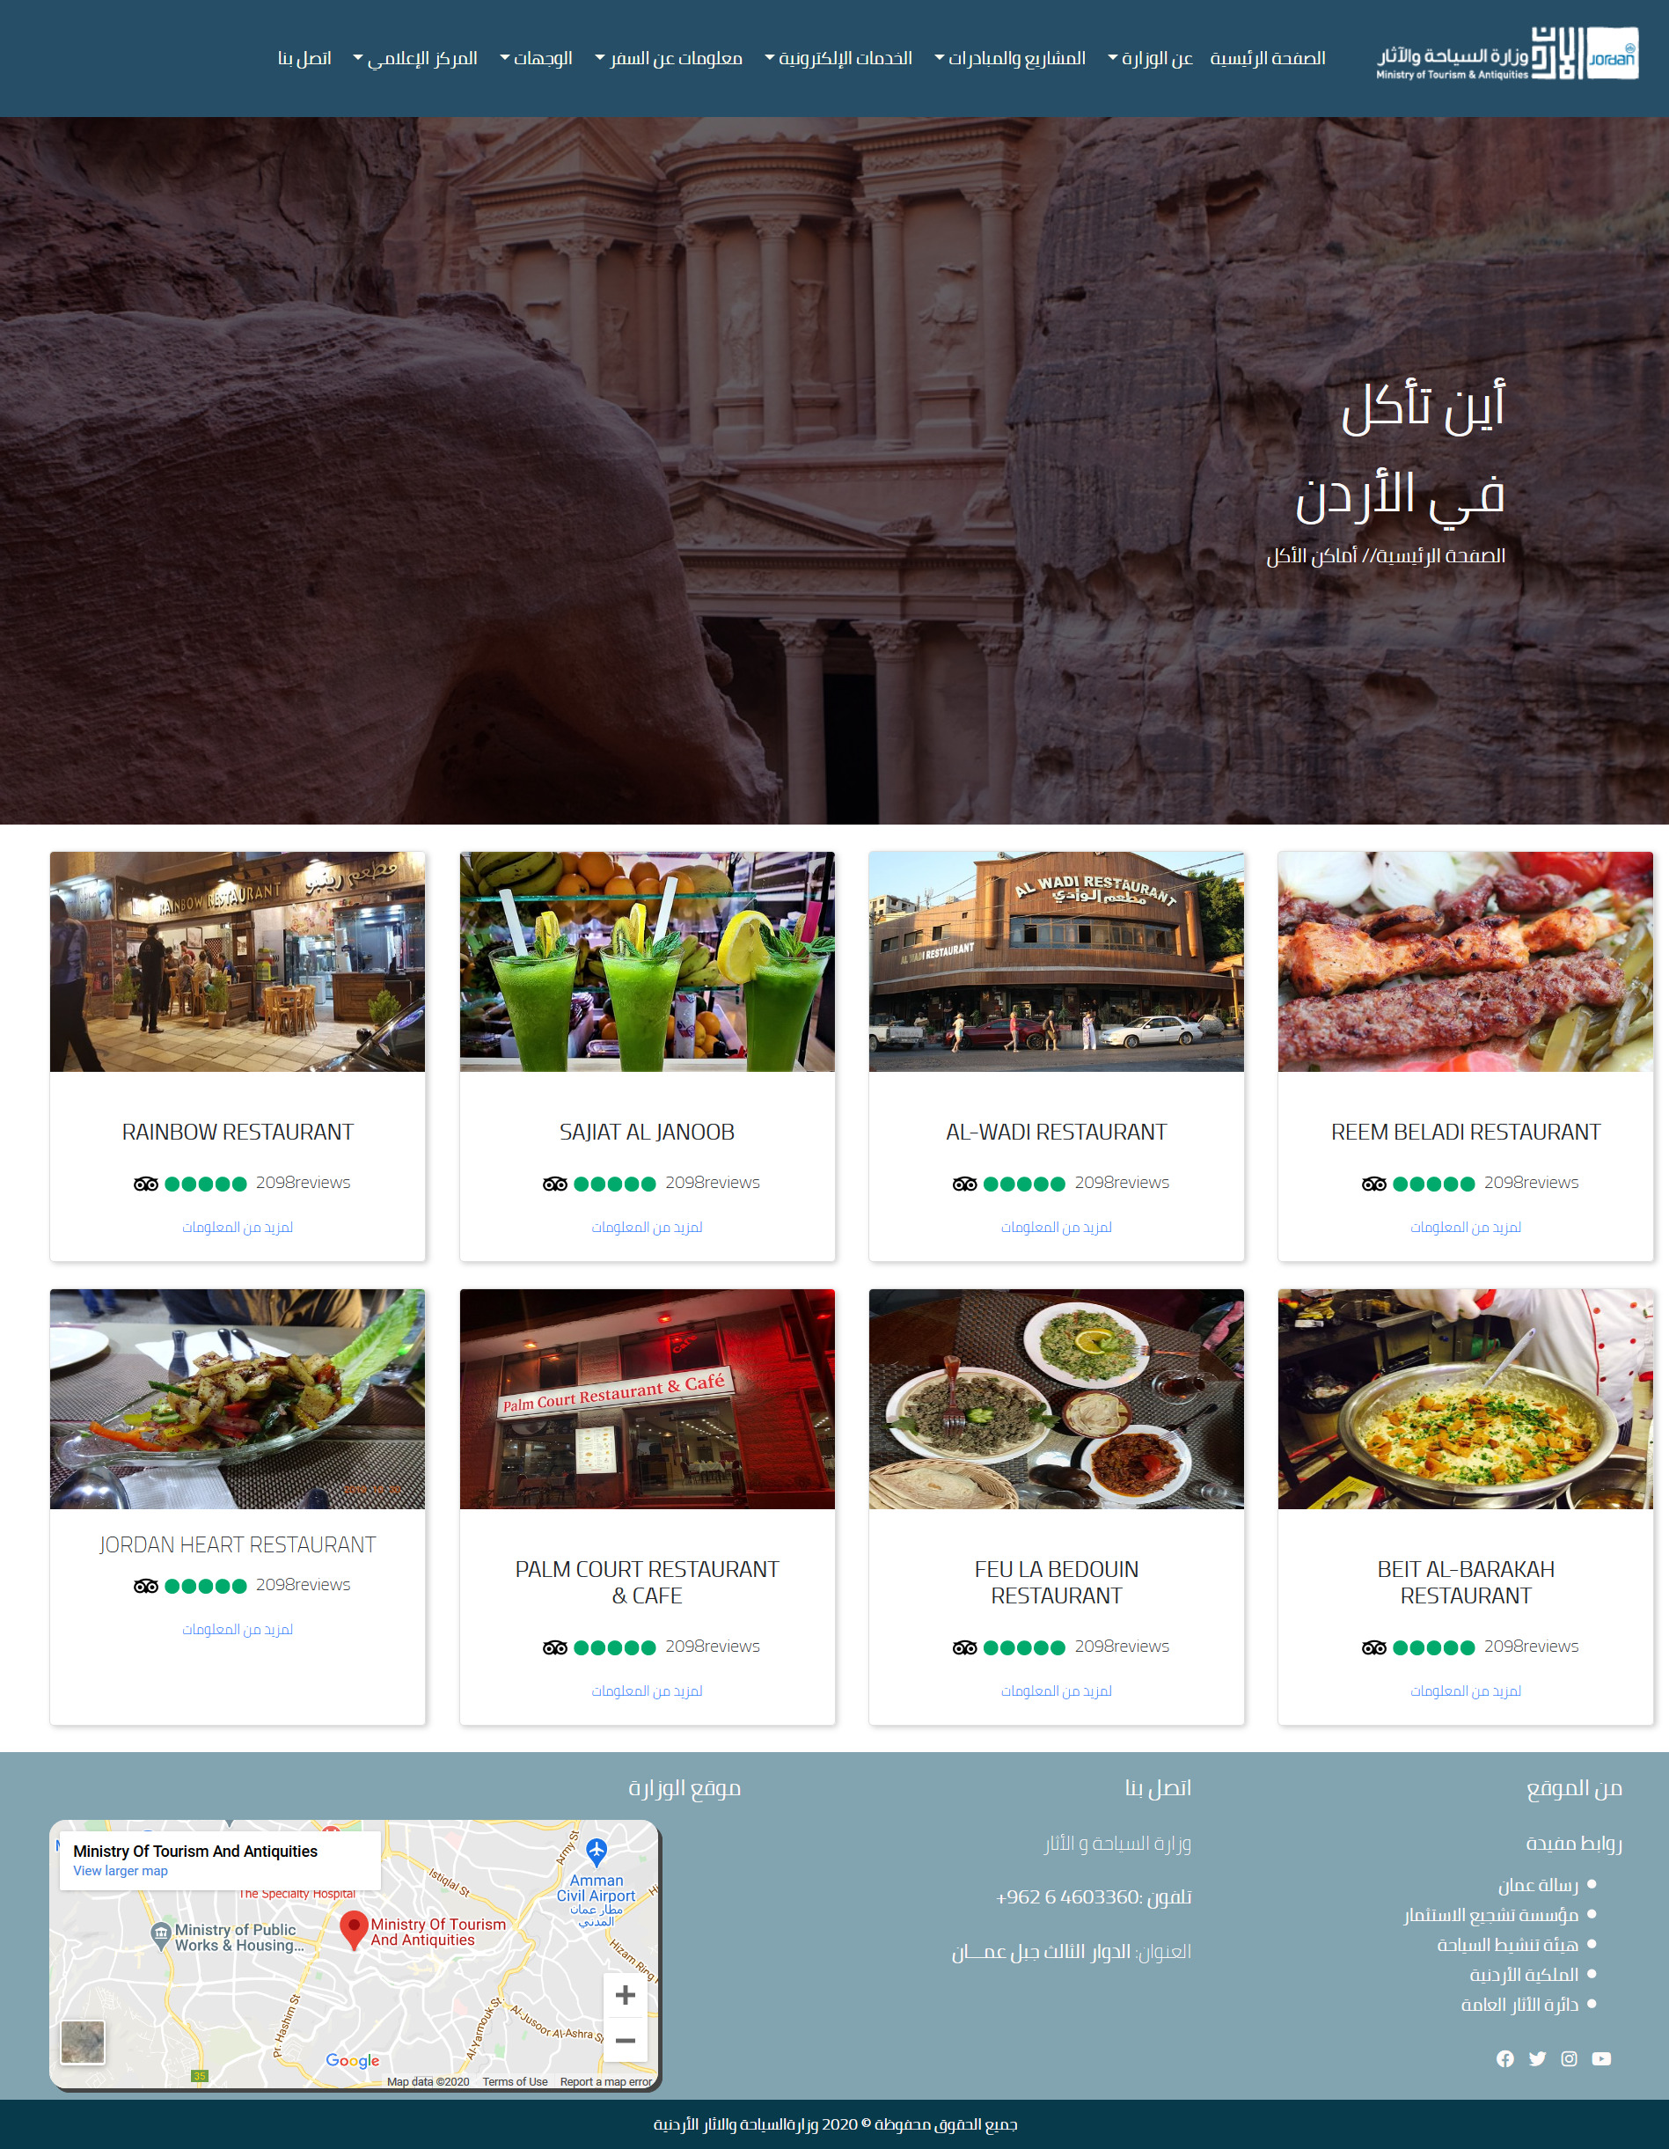

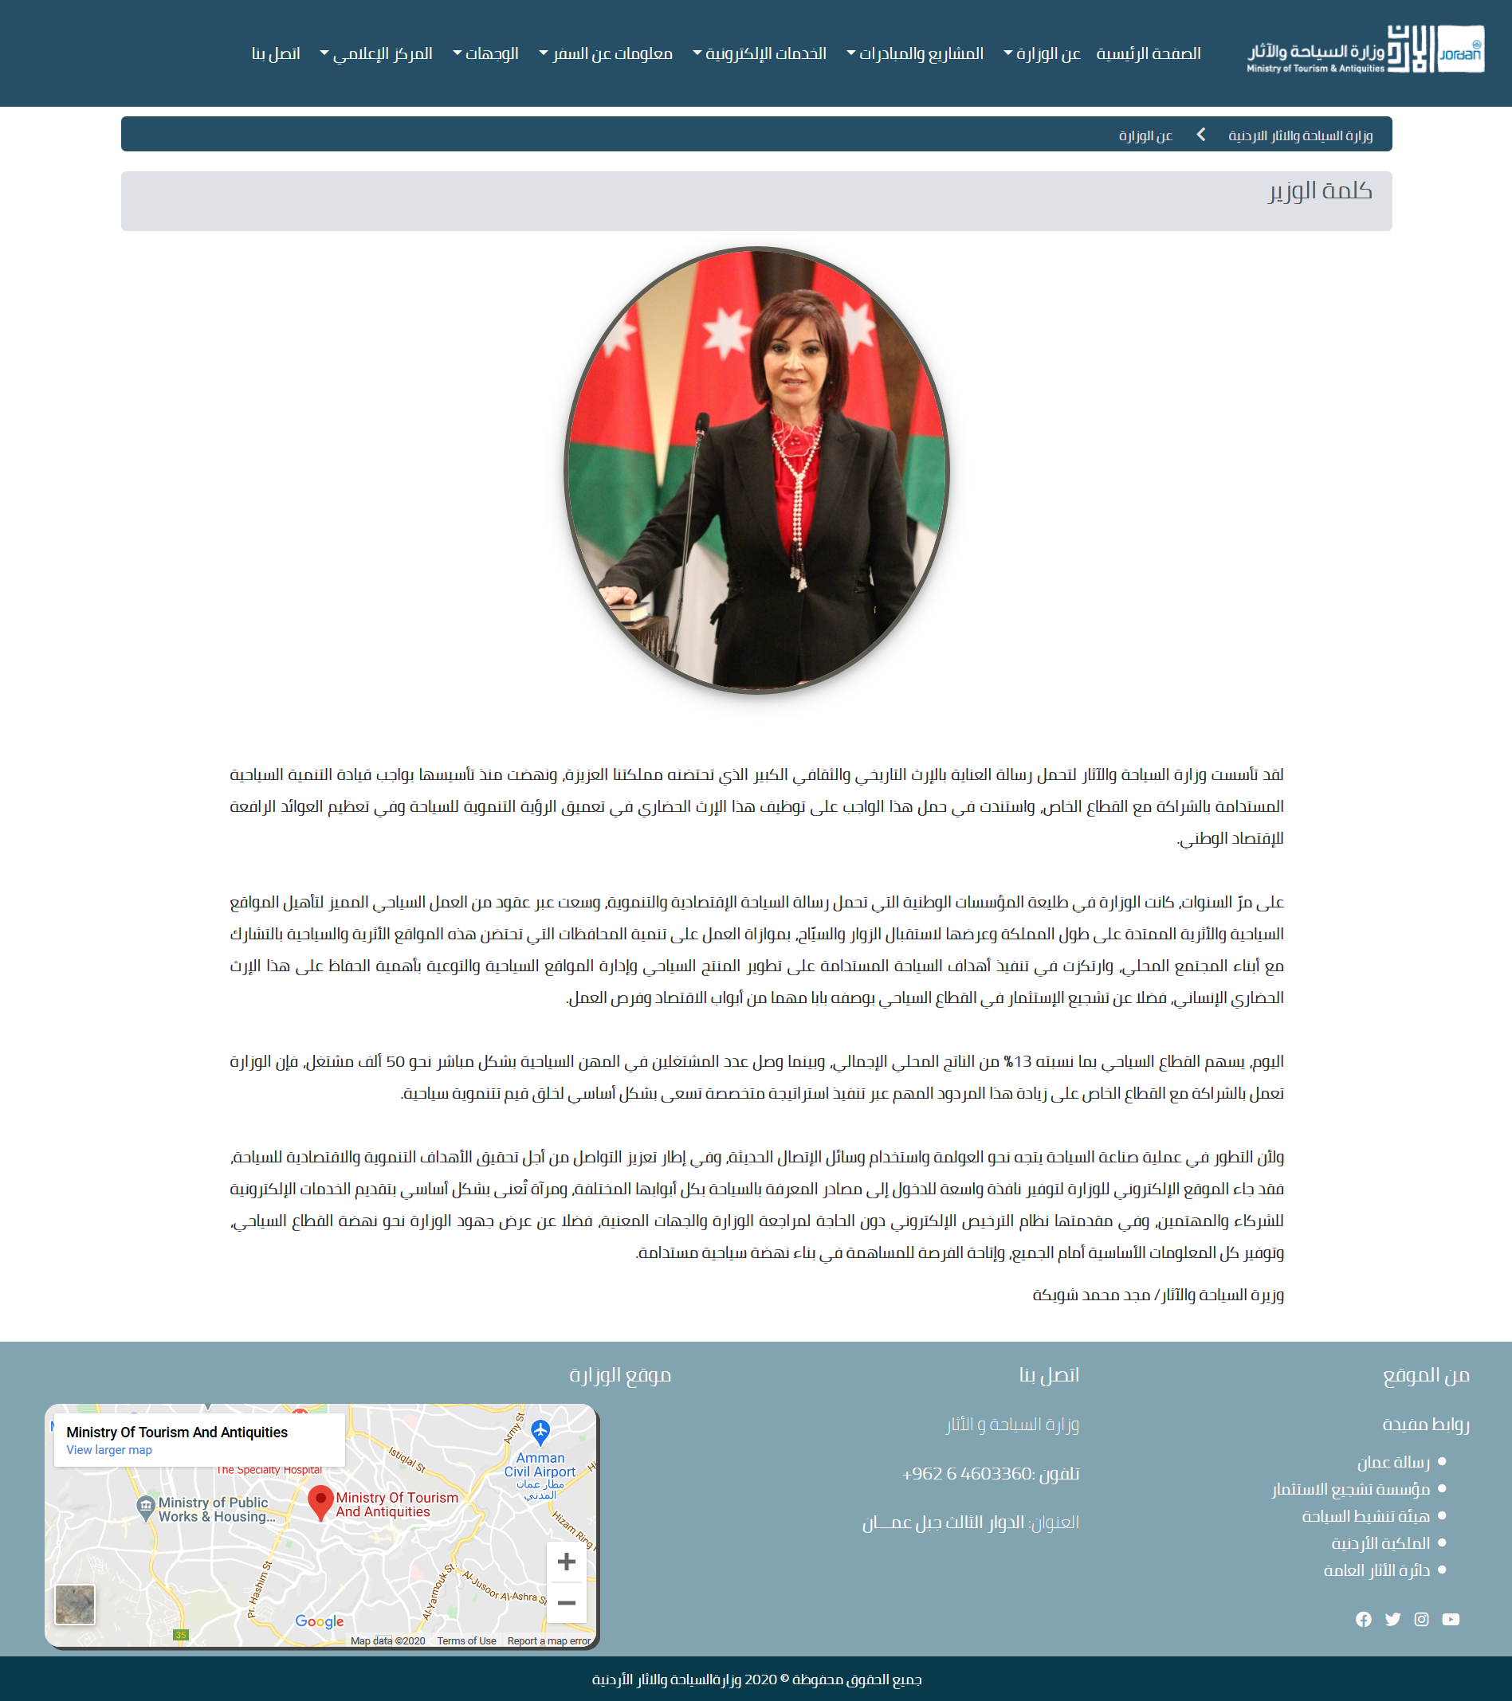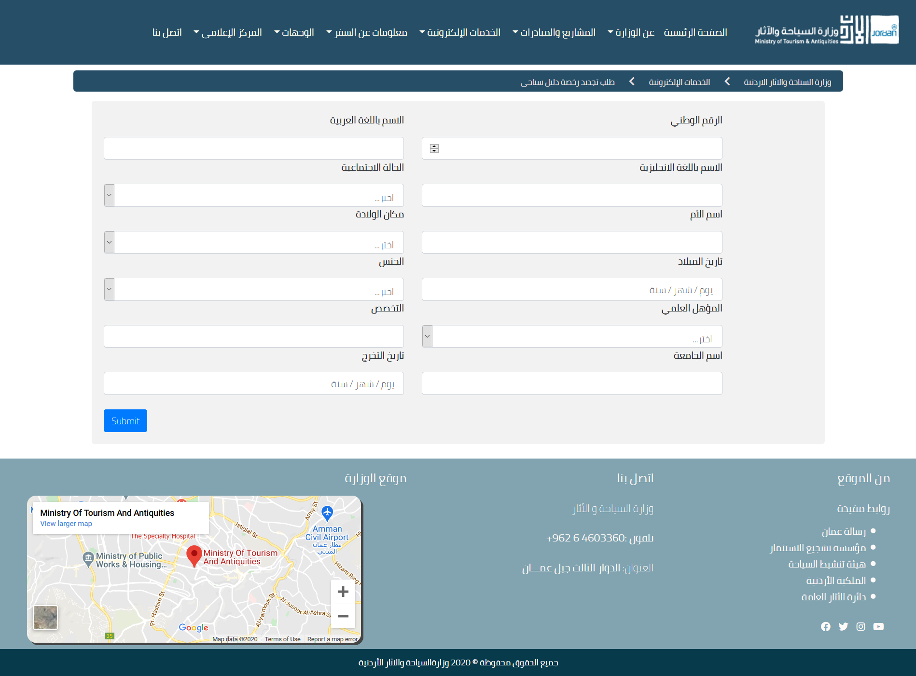

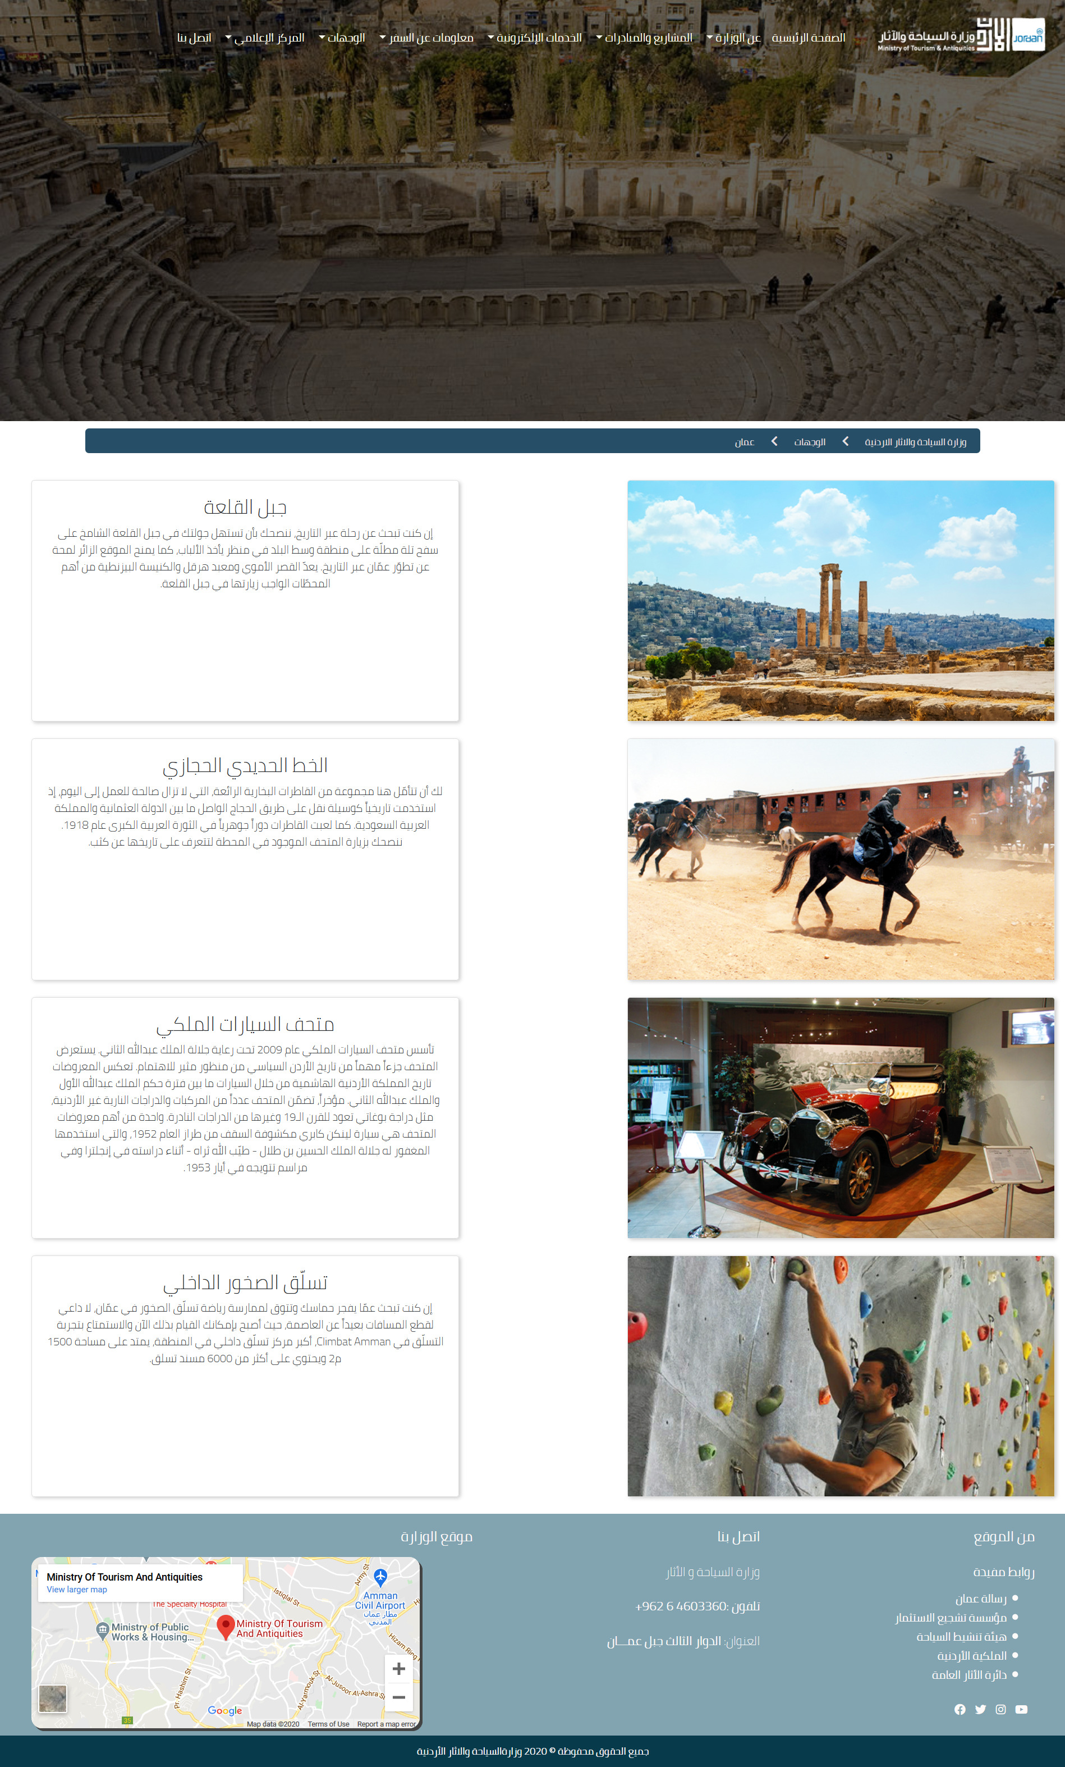

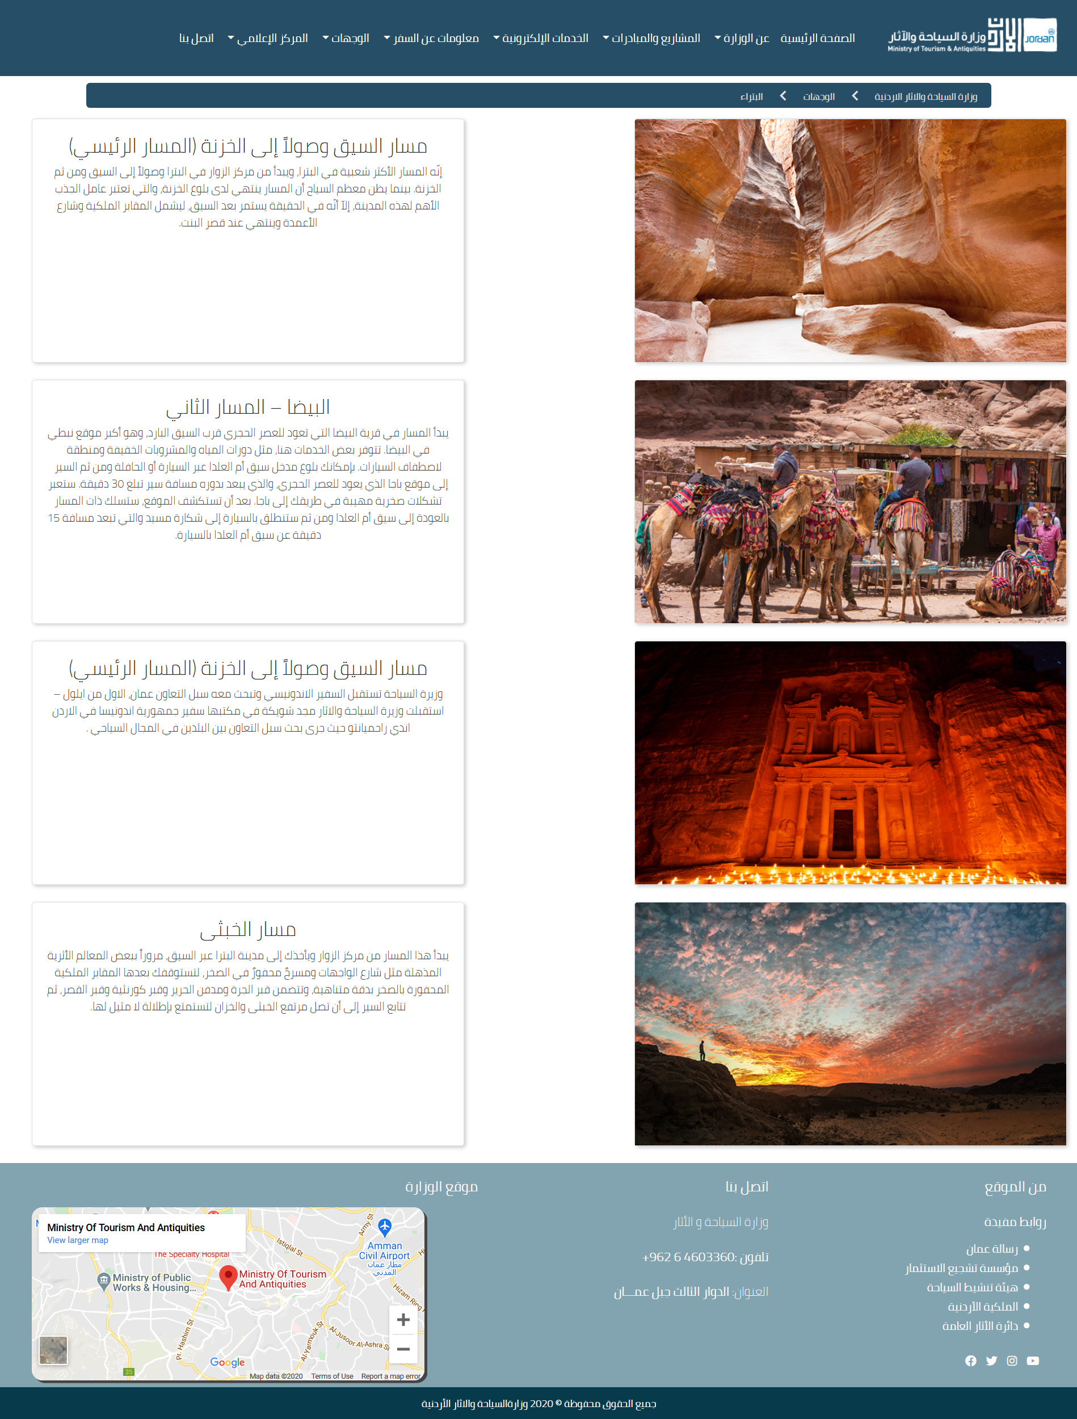

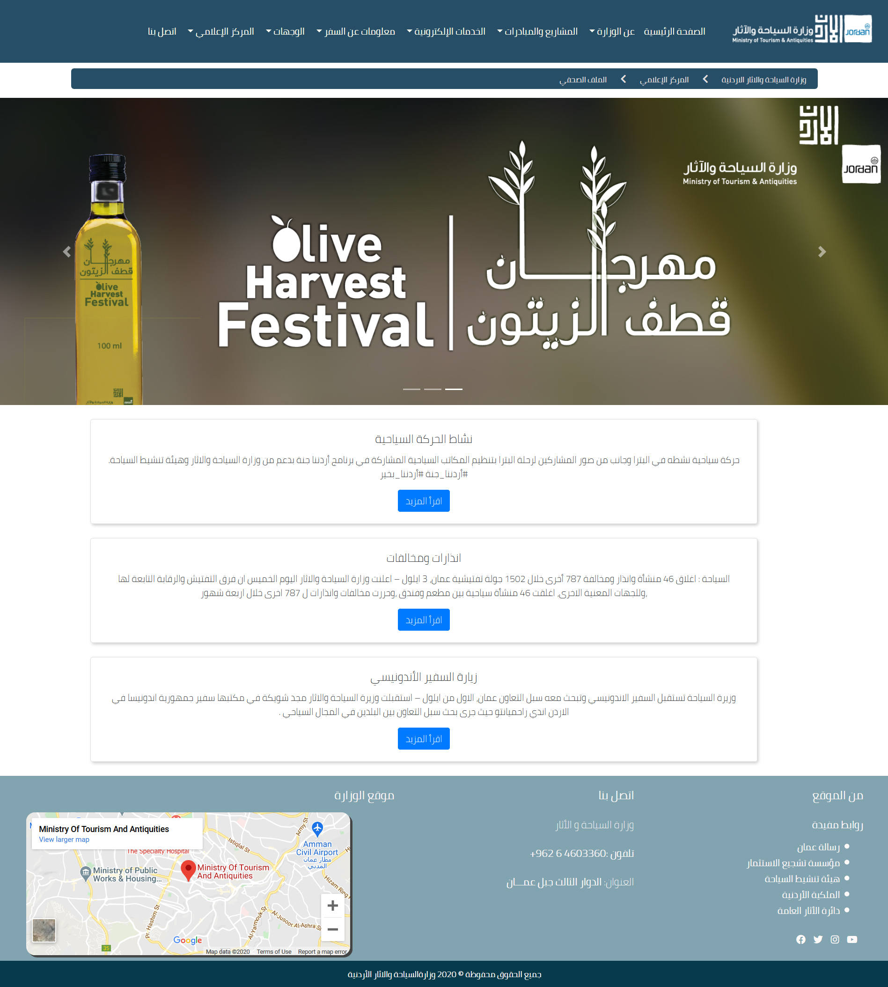

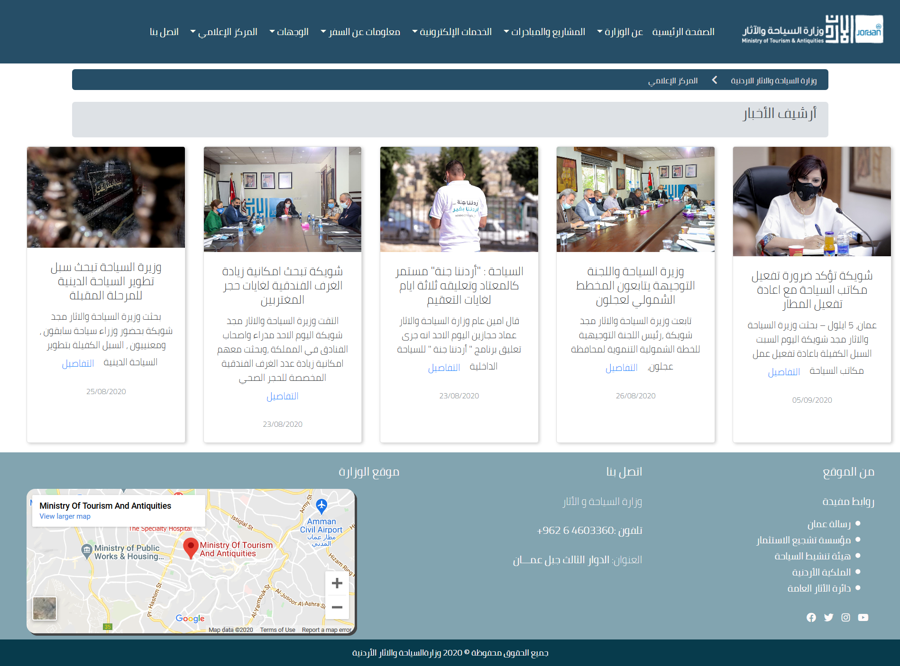

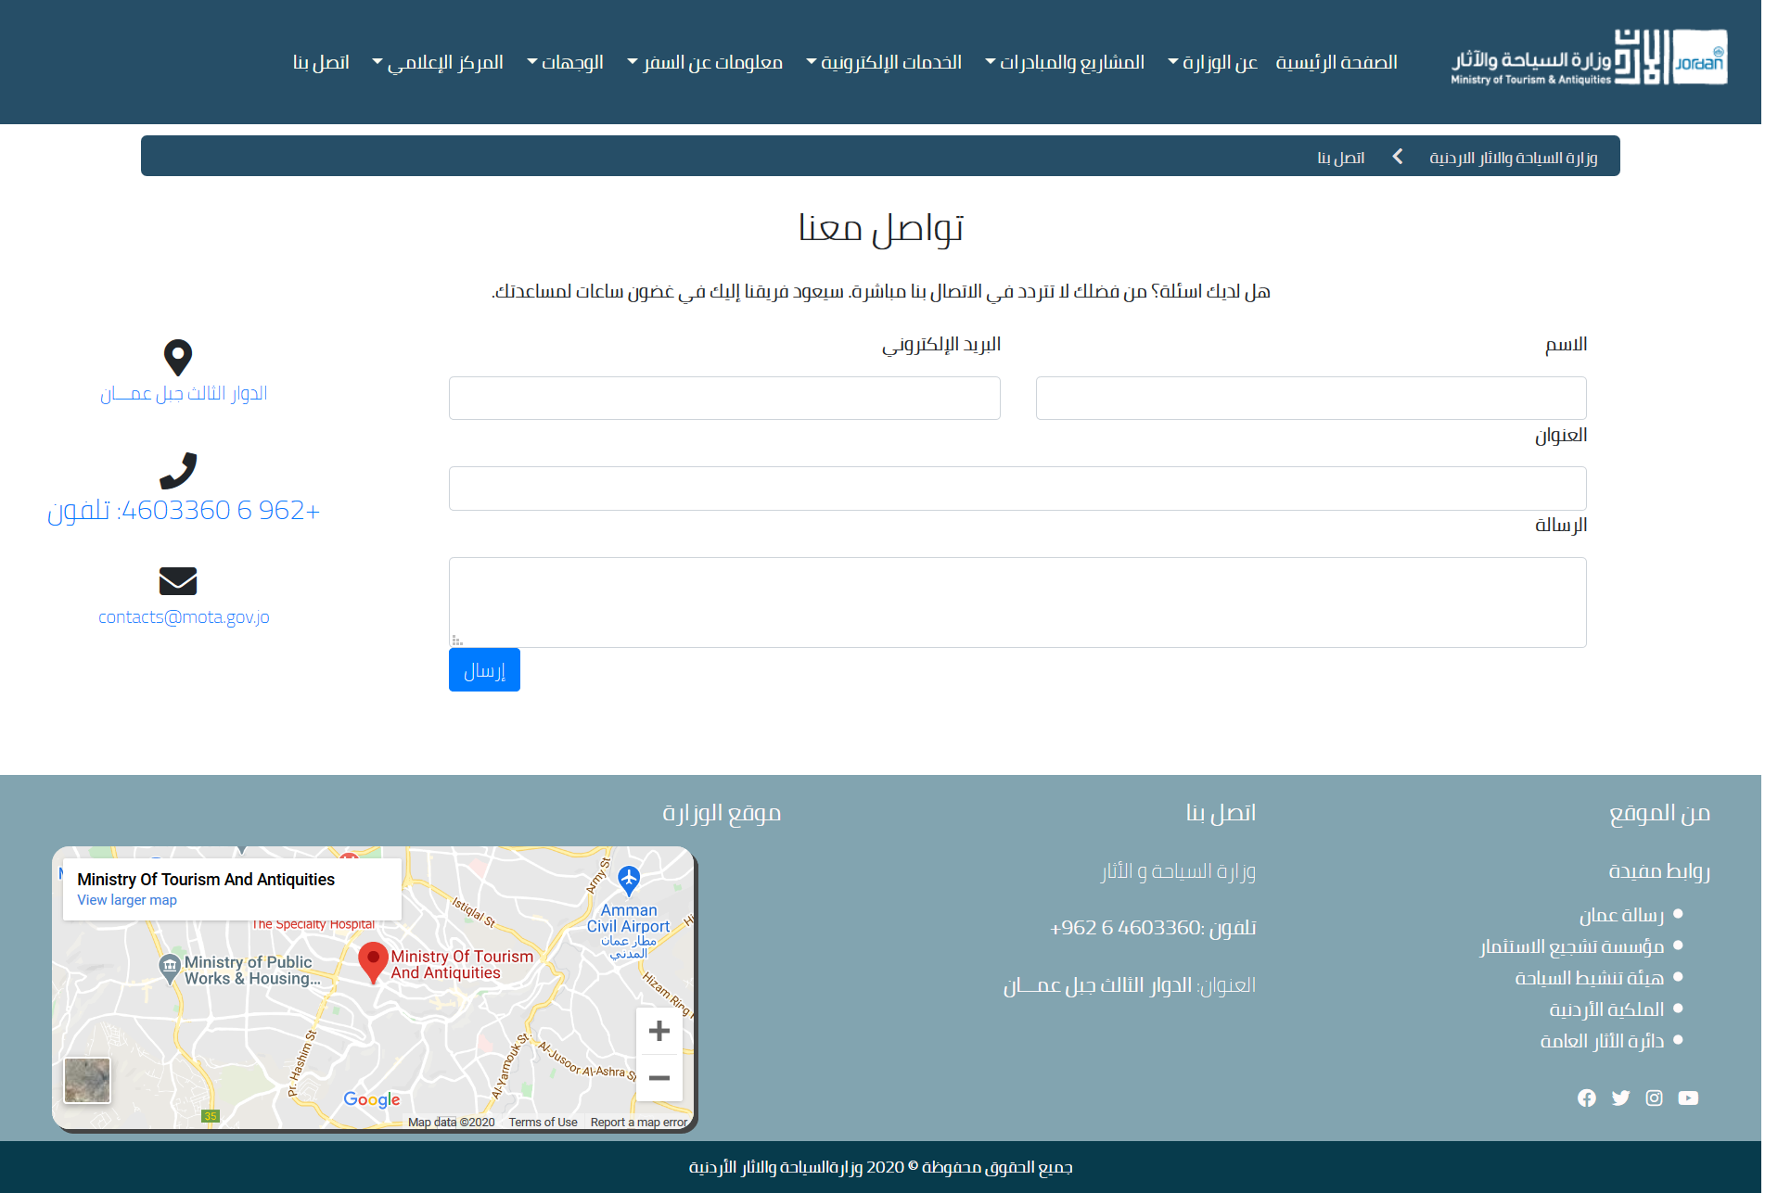

# Source Code Excerpts

<?php

include './config.php';

if(isset($_POST['name'])){

    $data= $mysqli->query("INSERT INTO `fyrhp`.`complient_information` (`name`, `mail`, `number`, `type`, `buildname`, `subject`, `compliment`)

    VALUES ('$_POST[name]', '$_POST[mail]', '$_POST[number]', '$_POST[type]', '$_POST[buildingname]', '$_POST[subject]', '$_POST[comptxt]');");

    if($data)

    echo '<script>

    function show_alert() {

        alert("لقد قمت بتقديم الشكوى بنجاح");

    }

    show_alert();

</script>';

    else

    {echo 'Erorr';

    echo $mysqli->error;

    }

};

?>

    <script>

    var arname=document.forms['contact-form']['name'];

  var arnameerror=document.getElementById('arnameer');

  arname.addEventListener('textInput',arnameVerify);

  var ID=document.forms['contact-form']['number'];

  var IDerror=document.getElementById('Iderror');

  ID.addEventListener('textInput',IDverify);

  var enname=document.forms['contact-form']['buildingname'];

  var ennameer=document.getElementById('engnameer');

  enname.addEventListener('textInput',engnameverify);

  var IDD=document.forms['contact-form']['comptxt'];

  var IDerroor=document.getElementById('Iderroor');

  ID.addEventListener('textInput',IDDverify);

      function validated(){

        if(arname.value.length<6){

  arnameerror.style.display="block";

arname.focus();

return false;

  }

  if(ID.value.length<10){

IDerror.style.display="block";

ID.focus();

return false;

  }

  if(enname.value.length<6){

  ennameer.style.display="block";

enname.focus();

return false;

  }

  if(IDD.value.length<6){

  IDerroor.style.display="block";

IDD.focus();

return false;

  }

    }

  }

  function engnameverify(){

    if(enname.value.length>6)

    {

      enname.style.border ="1px solid Silver";

      ennameer.style.display="none";

 return true;

    }

  }

  function IDDverify(){

    if(IDD.value.length>6)

    {

      IDD.style.border ="1px solid Silver";

      IDerroor.style.display="none";

 return true;

    }

  }

</script>

<body >

  <nav class="navbar navbar-expand-lg navbar-light "style="background-color: #264e67; ">

    <label class="logo"><img src="images/MOTALogo.png" /></label>

    <button class="navbar-toggler" type="button" data-toggle="collapse" data-target="#navbarNavDropdown" aria-controls="navbarNavDropdown" aria-expanded="false" aria-label="Toggle navigation">

      <span class="navbar-toggler-icon"></span>

    </button>

    <div class="collapse navbar-collapse" id="navbarNavDropdown">

      <ul class="navbar-nav article">

        <li class="nav-item ">

          <a class="nav-link" href="index.html" style="color: ivory;">الصفحة الرئيسية <span class="sr-only">(current)</span></a>

        </li>

        <li class="nav-item dropdown">

            <a class="nav-link dropdown-toggle" href="#" id="navbarDropdownMenuLink" data-toggle="dropdown" aria-haspopup="true" aria-expanded="false">

              عن الوزارة

            </a>

            <div class="dropdown-menu" aria-labelledby="navbarDropdownMenuLink" style=" text-align: right;">

              <a class="dropdown-item" href="minister'sword.html">كلمة الوزير</a>

              <a class="dropdown-item" href="organizationalchart.html">الهيكل التنظيمي</a>

              <a class="dropdown-item" href="conventions.html"> الاتفاقيات</a>

              <a class="dropdown-item" href="regulation.html">التشريعات</a>

              <a class="dropdown-item" href="ministryvision.html">الرؤية</a>

            </div>

          </li>

        <li class="nav-item dropdown">

          <a class="nav-link dropdown-toggle" href="#" id="navbarDropdownMenuLink" data-toggle="dropdown" aria-haspopup="true" aria-expanded="false">

            المشاريع والمبادرات

          </a>

          <div class="dropdown-menu" aria-labelledby="navbarDropdownMenuLink" style=" text-align: right;">

            <a class="dropdown-item" href="nationalstratigy.html">الاستراتيجيات الوطنية</a>

            <a class="dropdown-item" href="ministryprojects.html">مشاريع الوزارة</a>

            <a class="dropdown-item" href="bids.html">عطاءات الوزارة</a>

          </div>

        </li>

          <li class="nav-item dropdown">

            <a class="nav-link dropdown-toggle" href="#" id="navbarDropdownMenuLink" data-toggle="dropdown" aria-haspopup="true" aria-expanded="false">

                معلومات عن السفر                 </a>

            <div class="dropdown-menu" aria-labelledby="navbarDropdownMenuLink" style=" text-align: right;">

              <a class="dropdown-item" href="essintialinfo.html">معلومات اساسية</a>

              <a class="dropdown-item" href="where-to-eat.html">اماكن الاكل</a>

              <a class="dropdown-item" href="where-to-stay.html">اماكن البقاء</a>

              <a class="dropdown-item" href="transition.html">الوصول إلى والتنقل في</a>

            </div>

          </li>

          <li class="nav-item dropdown">

            <a class="nav-link dropdown-toggle" href="#" id="navbarDropdownMenuLink" data-toggle="dropdown" aria-haspopup="true" aria-expanded="false">

             الوجهات              </a>

            <div class="dropdown-menu" aria-labelledby="navbarDropdownMenuLink" style=" text-align: right;">

              <a class="dropdown-item" href="Amman.html">عمان</a>

              <a class="dropdown-item" href="deadsea.html">البحر الميت </a>

              <a class="dropdown-item" href="petra.html">البتراء</a>

              <a class="dropdown-item" href="aqaba.html">العقبة</a>

            </div>

          </li>

          <li class="nav-item dropdown">

            <a class="nav-link dropdown-toggle"   href="mediacenter.html" id="navbarDropdownMenuLink" data-toggle="dropdown" aria-haspopup="true" aria-expanded="false">

              المركز الإعلامي

            </a>

            <div class="dropdown-menu" aria-labelledby="navbarDropdownMenuLink" style=" text-align: right; align-items: left;">

              <a class="dropdown-item" href="news.html">الاخبار</a>

              <a class="dropdown-item" href="Journalisimfile.html">الملف الصحفي</a>

            </div>

          </li>

        <li class="nav-item">

            <a class="nav-link" href="contactus.html" style="color: ivory;">اتصل بنا</a>

          </li>

      </ul>

    </div>

  </nav>

# Conclusion

After deep analyses and research of the needs of Ministry of Tourism website, I tried my best to come up with an attractive useful website that provides a rich information for the visitor that helps him to know more about the Ministry of Tourism and tourism sites in Jordan. In addition to the facilities and hotels in this vital sector. The web site also covers the latest news Journalism file of the Mistry. Also, it contains general information about the Ministry such as the minster word, organizational chart, compensations, regulations, and ministry projects and beds.

وزارة السياحة والاثار الاردنية

الصفحة الرئيسية

معلومات عن السفر

عن الوزارة

المركز الاعلامي

المشاريع والمبادرات

الوجهات السياحية

الخدمات الالكترونية

معلومات اساسية

اماكن الاكل

اماكن البقاء

كلمة الوزير

الهيكل التنظيمي

الاتفاقيات

التشريعات

الملف الصحفغي

الأخبار

الاستراتيجيات الوطنية

عطاءات الوزارة

مشاريع الوزارة

العقبة

البحر الميت

البتراء

عمان

اتصل بنا

الذهاب الى والتنقل فيها

طلب تجديد رخصة دليل سياحي

تقديم شكوى على منشأة سياحية

طلب تدريب طلاب المنح